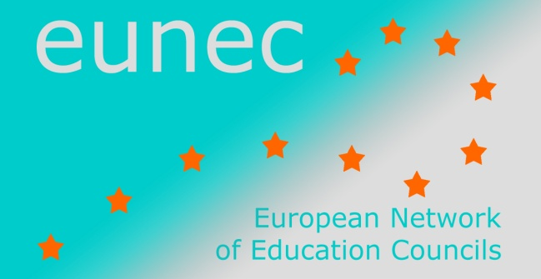

Seminar on ‘Community schools’

Brussels, 23-24 May 2013

INPUT FROM EUNEC MEMBERS

Hungarian Education Council

In Hungary the policy debate during the last decade took place in the schools and the local community affair. The discussion of the policy makers and of members of the present government was solved by legislation. Government took over the management, the issue of financing the majority of schools from January 2013. Most of the schools in Hungary from January 2013 became state run schools, (about 3000 schools). There is no real debate between school and local community. The institutions will now solve local professional autonomy in educational programs provided by the designated tasks, but 90 per cent of the local curriculum is a core curriculum which can be reported by only 10 per cent plus by each one school to the content or add more custom tinted.
This definition set forward by EUNEC, of course, is relevant, but at the current transformation of the entire public educational system, there are mainly the central questions of equality in the treatment of identity, and overall fairness.
In Hungary there is the economic autonomy of the individual schools is lacking. Everybody knows that professional autonomy without an economic playing field is just a blank password, and the law gives only professional autonomy to the schools, and nothing in the field of decision about the financial part of the regulation. The budget without freedom is not dependent on any local institution, which is a highly centralized system, and it is not able to respond to local needs and specialties. It is also evident that the advertised minimum conditions of quality improvement for sure, cannot be guaranteed in a 120 thousand teachers employed maintaining large public organization.
In Hungary, the Community Schools staff is primarily religious or celestial, this may appear as a foundation maintenance. From this point of view it is radically different from the multifunctional schools. It is likely they will survive if the operation can be centrally controlled. The school is a multi-purpose local capacity building. However, for the maintenance of the present highly centralized economy, transparency, predictability of funding makes it difficult for them to survive.
Basically, the debate on equal opportunities is the main current perspective. At the same time the educational policy constantly emphasizes raising the standards and raising the levels of learning issues, but without the economic aspect of the question. It is treated as a theoretical problem.
Formal and informal learning are integrated, but but it is mainly only in some institutions where innovative workshop operate with real practice.
Multi-functionality of the school buildings is very often talked about. However, without considerable financial investment in the development of school buildings due to a lack of funding, this is not a relevant issue in most parts of the system. Even the new national "daily exercise" can only be realized in a limited way, because there is no suitable size equipped gymnasium and sports hall in a substantial part of the public schools. Changing school buildings is almost impossible without planned investments into education, what is not visible at the current period.
The members of the National Public Education Council consider basically that decentralized solutions are technically adequate. They find important the embeddedness and the partnership of schools with the local community, but the local community lost its importance during the last few years period of strong centralization. The "partnership" in the current period rather acts as a slogan, or political campaign vocabulary.
At the moment, we observe with a great interest in international, particularly the European Union's proposals, the implementation of which our country could only be present at the level of professional debate. In the next two years in our country a radical centralization of the system as a whole takes place.

