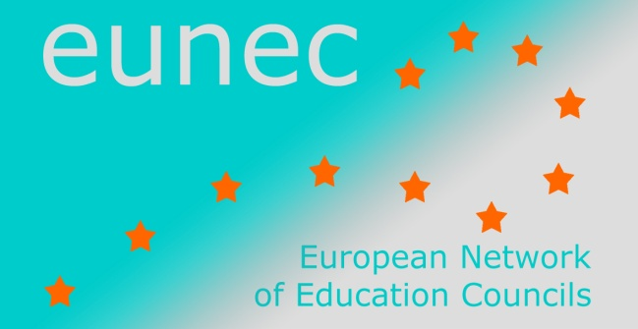
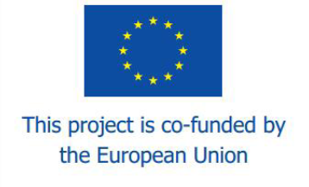

Seminar on

‘Learning in the digital age’

Athens, 5-6 May 2014

LIST OF PARTICIPANTS
Dionysios Anapolitanos President of the Council for the Primary and Secondary Education
Carmel Borg Member of the National Curriculum Framework Implementation Review Board, Malta
Spiros Borotis Research Manager, MENON network Athens
Petre Botnariuc Institute of Educational Sciences (IES), Romania
Agnė Brandišauskienė Education Council Lithuania
Boglárka Budai Public Education Council Hungary (intern)
John Chrysoulakis President of the Council for the Higher Technological Education, Greece
Alexandre Homem Cristo Portuguese Education Council
Carine De Smet EUNEC secretariat
Manuel Dony President CEF (Education and Training Council of the Federation Wallonia-Brussels, Belgium)

Mia Douterlungne EUNEC general secretary and general secretary of the Vlor (Flemish Education Council)
Ricardo Ferreira European Commission, DG Education and Culture
Elena Hadjikakou Cyprus Pedagogical Institute
Roos Herpelinck Vlor (Flemish Education Council)
Sokratis Katsikas President Greek National Council of Education
Marco Kools OECD Analyst, Innovation and Measuring Progress Division, Directorate for Education and Skills

Athanasios Kyriazis General Secretary of the Greek Ministry of Education and Religious Affairs

Jean Pierre Malarme CEF (Education and Training- Council of the Federation Wallonia-Brussels, Belgium)
Manuel Miguéns Secretary general CNE (Portuguese Education Council)
Tomás Ó Ruairc Director of the Irish Teaching Council
Demetrios G. Sampson Professor at the Department of Digital Systems, University of Piraeus, Greece
Konstantin Scheller European Commission, DG Education and Culture
Angela Soufli Greek National Council of Education
Vilija Targamadzė President Education Council Lithuania
Alfons ten Brummelhuis Head of Research Kennisnet, Netherlands
Liis Turu Estonian Education Forum
Adrie van der Rest EUNEC president and secretary director of the Onderwijsraad (Dutch Education Council)
Jiri Zajicek President Unions of Schools’ Associations, Czech Republic

