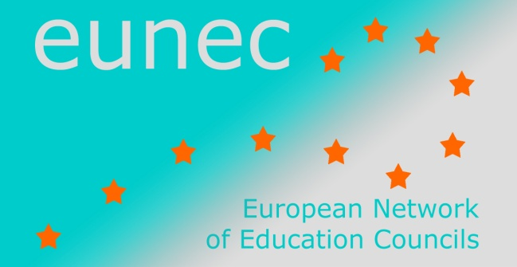
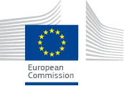

Seminar on

‘Community schools’

Brussels, 23-24 May 2013
LIST OF PARTICIPANTS
Magdalena Balica Educational Policy Department, Institute of Educational Sciences (IES), Romania
Celia Blomeley GTCW (General Teaching Council for Wales)
An Claeys General coordinator community schools Brussels
Carine De Smet EUNEC secretariat
Manuel Dony President CEF (Education and Training Council of the Federation Wallonia-Brussels, Belgium)

Mia Douterlungne EUNEC general secretary and general secretary of the Vlor (Flemish Education Council)
Alan Dyson Professor of Education, Centre for Equity in Education, University of Manchester
Carmo Gregório CNE (Portuguese Education Council)
Elena Hadjikakou Pedagogical Institute, Cyprus
Marieke Heers PhD student Maastricht University
Roos Herpelinck Vlor (Flemish Education Council)
Miloslav Hons Headmaster of primary and lower secondary school, Czech Republic
Viive Jüriso Estonian Education Forum
Aiste Laurinaviciute Education Council Lithuania

Jean Pierre Malarme CEF (Education and Training- Council of the Federation Wallonia-Brussels, Belgium)
Manuel Miguéns Secretary general CNE (Portuguese Education Council)
Jan Panhuyzen Vlor (Flemish Education Council)
Susan Rivers GTCW (General Teaching Council for Wales)
Dirk Schoofs Vlor (Flemish Education Council)
Vilija Targamadze President Education Council Lithuania
Sokratis Katsikas President Greek National Council of Education
Tas Szebedy President Public Education Council Hungary
Adrie van der Rest EUNEC president and secretary director of the Onderwijsraad (Dutch Education Council)
Job Van Velsen Project manager Dutch coalition for community Schools
Piet Vervaecke Director Education Centre Brussels
Chris Wyns Vlor (Flemish Education Council)

