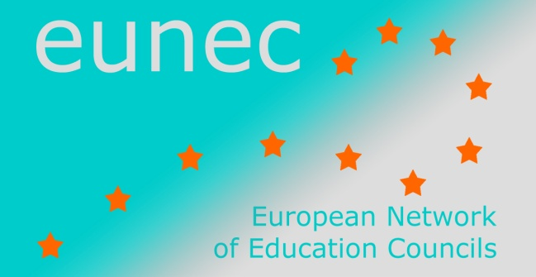
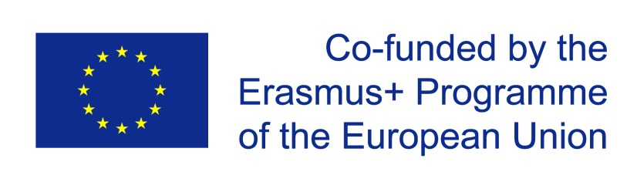

Conference

‘Bridging the transition between education and the labour market’

Prague, 20-21 October 2014

Final programme

Central question

Previous work of Eunec
Vocational education and training (VET) are already many years high on the agenda of Eunec and of the member education councils. The Copenhagen declaration of 2002 was a starting point for reflection and policy advice aiming at raising the profile of vocational education and training from the perspective of lifelong learning and integration of different learning pathways.
- In 2006 the concept of key competences for vulnerable groups was discussed and developed.
- In 2007 Eunec discussed the first drafts for transparency instruments for VET: the European Qualifications Framework (EQF) and the feasibility of a European Credit System for VET.
- In 2008 the central question of the conference was the paradigm shift towards learning outcomes. Learning outcomes were seen as a common and underlying concept for renewal of both general and professional educational strands. This was the case in compulsory education as well as in adult learning because competences acquired in non- formal learning strengthen the concept of lifelong learning.
- In Budapest, in 2009, Eunec debated on the concept and structures for guidance.
- In Lisbon, in 2011, the focus of the conference was on the relationship between the attractiveness of VET and of adult learning on the one hand and between VET and Science, Technology, Engineering and Mathematics (STEM) on the other hand.

Relevance of the theme
This theme is relevant for different reasons:
- Young citizens paid a high price for the current economic crisis. From the second quarter of 2008, the youth unemployment rate has taken an upward trend peaking in 23,6 % in the first quarter 2013, before receding to 23.1 % at the end of the year (Eurostat). Another worrying phenomenon is the ongoing skills mismatch between the competences and competence levels of those leaving the school and the competences and competence levels needed in a ‘learning economy’.
- The transitions between education and labour market are therefore a main strategic line in the working programmes of all education councils as it is also a common red line in the national education policies.
- The theme is also high on the EU-agenda, in the Europe 2020-strategy in general and in the Communication on apprenticeships in particular (DG Employment). The theme is also part of the ongoing work in the development of common instruments for transparency in the slipstream of the Copenhagen Declaration.

Central question for the conference
This conference is adding a different angle and a new perspective to the Eunec work already done. Based on discussions of the executive committee and the preparatory working group, Eunec decided to explore in depth the strategies to facilitate the transitions between VET and the (re)integration of youngsters on the labour market. How can society and the education and training systems organize broader and better established bridges between both worlds and this in two directions ?
More specifically, this conference will consider alternative training pathways in the transition between learning and working, in partnership between education and employment. The focus will be on apprenticeships and work based learning in a broad sense.
We would also like to offer a ‘panorama’ of programmes that try to ease the transition. We found inspiration in an interesting inventory published by CEDEFOP. Those programmes exist in different Eunec member countries (Ireland, Lithuania, Cyprus, Belgium (French Community), ..). Eunec invited its members to make an active contribution to this conference and to give a presentation of their programme, which will then be discussed in smaller interactive working groups.
The conference will explore this central question from different angles and perspectives.
The first perspective is the one of the skills needed beyond the school and the competences required in a quickly evolving and highly competitive labour market, in a perspective of a sustainable development in professional and personal life and as citizen. This includes reflection on labour market needed competences, lifelong participation and inclusion, career management.
A second perspective is on transitions from both professional education at secondary level and higher education to the workplaces.
- A way of bridging the gap between labour market and the world of education and training is to give pupils a real labour market experience, on the work flour, in or outside the school, during the training pathway or afterwards. The European Commission is promoting both apprenticeship and work based learning. Both concepts are rather confuse and can be organized under different shapes. These concepts offer space for debate to Eunec members. A specific feature of learning in the workplace is the German dual learning. Dual learning is being strongly promoted in recent documents by the European Commission. Eunec invited the Bertelsmann Stiftung from Germany to present the materials that they have developed.
- The focus will also be on short cycle professional higher education (SCHE). Short cycle higher education is an new trajectory for learners aiming at a professional qualification at an ‘intermediate’ level between level 4 and 5 of the European qualification structure. Labour market is in need for this medium qualified skilled workers in specialized sectors of the economy (e.g. technicians, health care workers). This ‘new’ education level allows to train pupils for the labour market without aiming a bachelor or a master in higher education, whilst the transition to higher education remains possible. Several European countries are building such learning pathways under different shapes.

Background documents

EUNEC conference on ‘New skills for new jobs’, Lisbon, October 2011

The European Commission initiative ‘New skills for new jobs’

Skills beyond School
The new OECD policy review of postsecondary vocational education and training, looks at the preparation of younger people and adults for technical and professional jobs. Key policy challenges include responsiveness to labour market needs, alongside inclusion, access, career guidance, finance, governance, teaching quality, integration with workplace learning, articulation with other sectors of education, and qualifications and assessment. It builds on the success of Learning for Jobs – which examined vocational education and training policy through 17 country reviews and a comparative report - and forms part of the horizontal OECD Skills Strategy linked to PIAAC and other initiatives across the OECD. It also draws on the OECD review of tertiary education.

EU Skills Panorama (2014) Apprenticeships Analytical Highlight
This paper is prepared by ICF GHK and CEDEFOP for the European Commission. The paper describes policy developments at national level, provides a checklist of key success factors for apprenticeships and insists on the benefits.

Programme
Monday 20 October
Chair of the day: Adrie van der Rest, EUNEC president
09.00 h – 09.30 h Welcome by EUNEC president, Adrie van der Rest, and by Jindřich Fryč, Director General, Section for Policy Coordination and International Affairs, Ministry of Education, Youth and Sports
09.30 h – 10.30 h ‘From education to working life: learning for employability’, key note by Lore Schmid, senior expert at CEDEFOP, with questions and answers
10.30 h – 11.00 h Coffee break
11.00 h – 11.30 h Panorama of good practices: Czech Republic (1). ‘Educational sector and labour market cooperation in the Czech Republic’ by Petr Bannert and Pavel Hradecký, Ministry of Education
11.30 h – 12.00 h Panorama of good practices: Czech Republic (2). Presentation by Miloš Rathouský, Confederation of Industry
12.00 h – 13.00 h Debate in parallel workshops
13.00 h – 14.00 h Lunch
14.00 h - 17.00 h School visit: presentation, visit and laboratory workshop
17.00 h Free evening

Tuesday 21 October
Chair of the day: Mia Douterlungne, EUNEC secretary general
09.00 h – 10.00 h ‘Vocational education and training: the OECD experience’, key note by Jose-Luis Alvarez-Galvan, OECD, including a presentation of the ‘Skills beyond School’ project, with questions and answers
10.00 h – 10.30 h Panorama of good practices: ‘Implementation of ECVET, a challenge for all the stakeholders’, by Alain Bultot, EQF and ECVET National Contact Point for Belgium (Be-Fr)
10.30 h – 11.00 h Panorama of good practices: ‘Good practices in Career counselling in Romania’, by Marcela Calineci, CMBRA/ISE
11.00 h – 11.30 h Coffee break
11.30 h – 12.30 h Debate in parallel workshops
12.30 h – 13.30 h Lunch
13.30 h – 14.00 h Panorama of good practices: Germany. Presentation of the study 'Germany's dual vocational training system: a model for other countries?' by Lars Thies, Bertelsmann Stiftung.
14.00 h – 14.30 h Panorama of good practices: Ireland. Presentation of the Review of apprenticeship training in Ireland by Fergal McCarthy, Chair of Education, Irish Teaching Council
14.30 h – 15.00 h Coffee break
15.00 h – 16.00 h Debate in parallel workshops
16.00 h Closing address by the president
18.30 h Conference dinner
Wednesday 22 October
09.00 h – 11.30 h Meeting of the executive committee (for EUNEC members only)
11.30 h – 12.30 h Meeting of the general assembly (for EUNEC members only)
12.30 h – 13.30 h Closing lunch

