|  |  |  |  |
| --- | --- | --- | --- |
|  |  |  |  |

**GUIDANCE THROUGH TRANSITION MOMENTS IN THE LEARNING PATHWAY**

**Report of the conference of the European Network of Education Councils,**

**Budapest, 13-14 October 2009**

**with the support of the European Commission**

**DG Education and Culture**

Brussels, January 2010

EUNEC secretariat, Kunstlaan 6, bus 6, 1210 Brussels + 32.2.219 42 99

[**www.eunec.eu**](http://www.eunec.eu)

INTRODUCTION

EUNEC is the **European Network of Education Councils**. Its members advise the governments of their countries on education and training. EUNEC aims to discuss the findings and recommendations of all European projects in education and training, to determine standpoints and to formulate statements on these issues. EUNEC wants to disseminate these statements pro-actively towards the European Commission, relevant DGs and other actors at European level, and to promote action by EUNEC’s members and participants at national level. EUNEC also has the objective that the councils should put internationalization and mobility high on the national agenda, that they should recommend and support a European policy in education and training towards all relevant stakeholders: ministry of education (and employment), sectoral and branch organizations, providers and other actors.

From 2008 EUNEC has been **subsidized** as **European Association acting at European level in the field of education** (Jean Monnet programme). This conference is organized with the support of this grant.

PROGRAMME

Tuesday 13 October 2009

***Simone Barthel*** *– President EUNEC, chair of the day*

**09.00 – 09.30 h Opening session**

**Welcome by Hungarian representatives**

**Mr Tas Szebedy**, vice-president of the Hungarian Education Council

**Mr Zoltan Loboda**, head of department at the Hungarian Ministry of Culture and Education; member of the OECD Committee for Educational Policy

**Challenges and new concepts for guidance**

**09.30 – 09.45 h** **Global context of Lifelong Guidance**

**Ms Simone Barthel**, responsible for the theme of guidance, CEF (Conseil de l’Education et de la Formation de la Communauté française de Belgique)

**Dr Raimo Vuorinen**, coordinator of the European Lifelong Guidance Policy Network, Finnish Institute for Educational Research, University of Jyväskylä.

*What are relevant developments and new perspectives for guidance? The Lifelong Learning perspective? The shift towards learning outcomes and qualification policies? Raising the qualification level and reducing the number of unqualified school leavers?*

*What does this mean for guidance policies, instruments and key players?*

**10.15 – 10.30 h Coffee break**

**The role of guidance at crucial transition moments**

*How can guidance, at different transition moments in education and life, empower learners to*

*- manage their career paths and develop their competences in the context of a turbulent labour market?*

*- develop competences for personal development and active citizenship?*

*- manage a successful learning pathway rewarded with a qualification?*

*What does this mean for guidance policies, instruments and key players?*

**10.30 – 12.10 h Round table: examples of good practice**

Contributions from education councils

* Transition moments in early childhood and primary education

**Ms Roos Herpelinck,** Flemish Education Council

* Transition moments during secondary education (general and vocational)

**Ms Pilar Calero López,** Consejo Escolar del Estado, Spain

**Ms Ana Bettencourt**, president of the Conselho Nacional de Educação, Portugal

* Transition moments towards tertiary education and VET

**Mr Mal Davies**,General Teaching Council for Wales

* Transitions to the labour market

**Ms Jana Váňová** and **Mr Jaromír Coufalík,** Czech National Training Fund

In each contribution the following questions will be addressed:

* the challenges
* the instruments and the key players

**12.10 – 13.00 h Innovative practices in the field of guidance in Hungary**

**Mr Borbely Pecze Tibor Bors**, PhD, expert in guidance practices, Scientific Advisor, Hungarian National Employment Service

**13.00 – 14.30 h Lunch**

**The role of guidance and the learning pathways of vulnerable learners**

**14.30 - 16.00 h Workshops**

Workshop 1: How can guidance support the learning pathways, the well-being and the school success of youngsters at risk of unqualified school leaving and of low achievers?

Workshop 2: How can guidance support the acquisition and maintenance of key competences, life skills and professional competences of vulnerable groups of adult learners (e.g. low qualified professionals, workers during a career reshuffle)?

For each working group, there will be a facilitator and a reporter.

Method: No key note speakers, but a common work, to share experiences and practices at different levels in the countries of the members.

**16.00 – 16.30 h Coffee break**

**16.30 – 17.30 h Conclusions from the reporters of the two workshops and debate**

**19.00 h Conference dinner – boat trip on the Danube**

**22.00 h Preparation of the statement proposals by the secretariat**

Wednesday 14 October 2009

***Simone Barthel*** *– President EUNEC, chair of the day*

**09.00 – 10.30 h Statements on lifelong guidance: discussion and approval. What will EUNEC propose to the national/regional councils and to the European Commission?**

**End of the conference**

**Opening Session**

THE HUNGARIAN EDUCATION SYSTEM

Tas Szebedy

Tas Szebedy is vice-president of the Hungarian Education Council

In Hungary, education is one of the strategic topics among main political issues.

The Ministry oversees the pedagogical, professional and educational efforts in public education. It is responsible for drawing up the necessary development plans, creating the legislation required for such operations and ensuring that the institutions work at the required standard of quality. To this end, it organises pedagogical, professional assessments, examinations and surveys in the field of public education. It ensures that children are supplied with high-quality textbooks by elaborating the order and conditions of schoolbook registration.

The Ministry is responsible for the public administration tasks relating to the valuable assets safeguarded in public collections (museums, libraries and archives). It also operates the relevant services, professional committees and councils.  
An important duty of the Ministry is to organise the State's public education activities and to support public education.

It furthers and coordinates the efforts of the professional contributors to cultural and tourist attraction projects.

The Ministry lays great emphasis on assisting and subsidising the cultural and educational work of Hungarians across the border and minorities in Hungary, as well as the provision of equal opportunities for children and young people with disadvantages. The Minister attaches special significance to his tasks related to ecclesiastic matters and church relations.

The Ministry also monitors and modifies existing and introduces new medals, awards and scholarships in education and culture.

In his international role, the Minister is often engaged in cooperation with other Ministers. Such work includes preparations for, and the conclusion of, educational and research agreements with other countries, the adoption of workplans, facilitating the overseas studies of scholarship holders, and carrying out the state tasks related to the education of Hungarians beyond the borders of the Republic of Hungary. The MEC also partakes in the overseeing of Hungarian cultural institutes.

It is independently responsible for the central steering of education for national and ethnic minorities in their mother tongues and the conclusion of international agreements concerning the acknowledgement of certificates, diplomas and scientific degrees.

The Minister of Education is Dr. PhD István Hiller. Gergely Arató is Senior State Secretary for Education.

Ferenc Csák is in charge of international relations; Dr. Károly Manherz is in charge of higher education and science; Dr. Márta Schneider is in charge of culture; Dr. János Szüdi is in charge of public education; Ferenc Závecz is in charge of financial affairs and administrative activities.

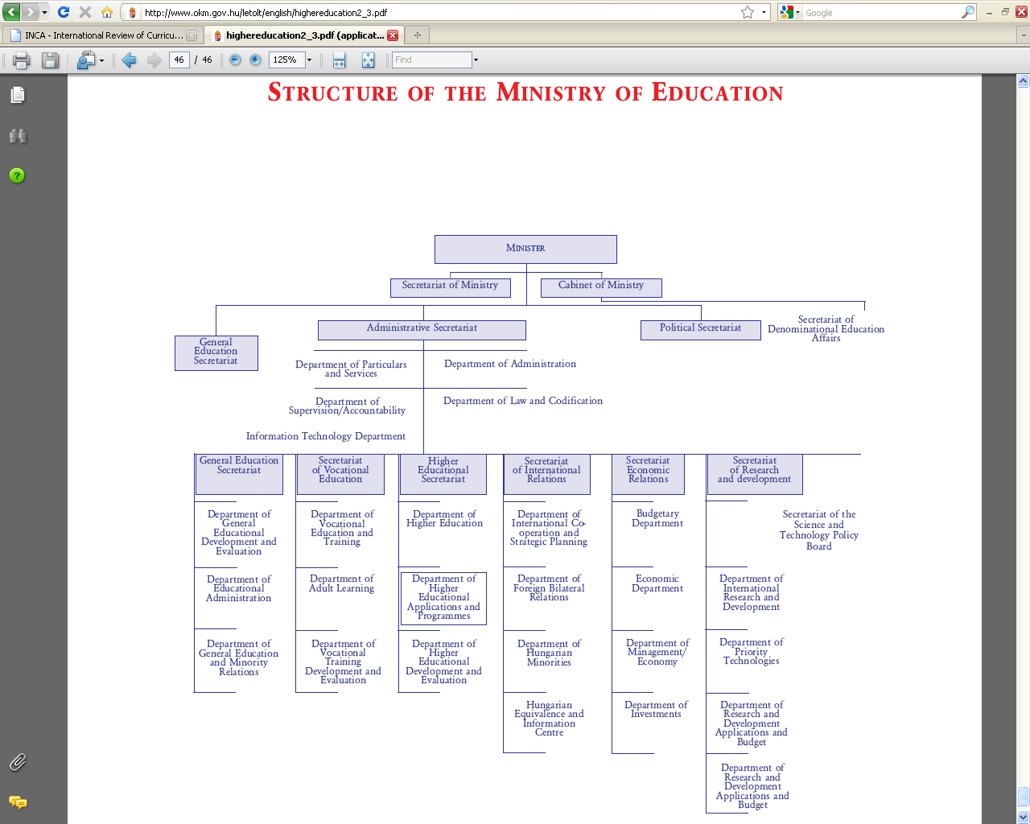

Several professional organizations are taking part in the preparation of new laws:

* National Public Education Council
* Public Education Policy Council
* Educational Authority
* National Council of Ethnic Minorities
* Over 100 Civil Educational Organizations are involved in the preparation of legal documents

Education population and language of instruction

In 2006 the number of people aged between 0 and 29 was 3 673 592, which is 36.63 % of the total population.

2 150 602 young people aged 5-18 were involved in compulsory education. The 87 % of the population aged 3-22 was enrolled in pre-primary, primary, secondary and tertiary education institutions.

The official language of instruction is Hungarian. Officially recognized ethnic and national minorities (e.g. German, Romanian, Slovenian, Serb, Croatian and Greek) have public minority educational institutions where their own language as first or second language of instruction is used.

Administrative control and extent of public-sector funded education

The predominant majority of children attend public-sector schools (kindergartens or schools), which are administered by public authorities, primarily the local governments. State and private institutions receive funding according to the same criteria.

The ratio of children at kindergartens and primary schools managed by non state maintainers is 5 %; in the case of secondary schools it is 28 %. The central budget provides normative financial support to all maintainers (state and non state).

Additional financial support (kiegészítő támogatás) is given for specific tasks and purposes that are stipulated by law. Basic education is free according to the core principle of the Hungarian education system.

Horizontally, the administrative responsibilities are shared between the Ministry of Education and Culture and other ministries: primarily the Ministry of Employment and Social Affairs, the Ministry of Finance and the Ministry of Local Governments and Regional Development.

National summary sheets on education systems in Europe and ongoing reforms.

Since 2006 responsibility for defining the content of school based vocational education has been transferred to the Ministry of Employment and Social Affairs, while the Ministry of Education and Culture continues to be responsible for the overall management of public and higher education.

Vertically, the tasks related to administrative control and management responsibilities are decentralized and are shared among the central (national) government, the local (county and/or community level) authorities and the respective educational institutions.

The overall control is the responsibility of the Minister of Education and Culture, whose authority covers all the issues and activities falling under the Act on Public Education irrespectively of where the activity takes place, in what kind of institution or who the maintainer of the institution is.

**National Public Education Council** (Országos Köznevelési Tanács) is the Minister’s professional advisory body – established by the Act on Public Education – which contributes to the preparations of decision-making, forms opinion and makes proposals.

**Public Education Policy Council** (Közoktatás-politika Tanács) takes a stand on issues regarding the public education and policy at national level.

**The Educational Authority** (Oktatási Hivatal) was set up in 2006. The Authority operates as a central office, under the control of the Minister of Education and Culture. It performs organisation and coordination of surveying, measuring, evaluation and quality assurance tasks regarding all levels of education.

Municipalities undertake tasks related to kindergarten and primary public education, and also secondary education. In case the secondary education presents difficulties, the tasks can be delivered to or shared with county/ capital (in Budapest) local governments.

Municipalities control the legacy of operation and management; make decisions about the establishment; specify the budget; supervise the economy and legal operation and the efficiency of professional work.

In the case of state-funded education, municipalities act as maintainer of the educational institutions. The maintainer appoints the head of the institution and practices the employer’s rights. Within the local and county governments notaries exercise the rights of authority.

Curriculum control and content

The education in pre-primary school (óvoda) is performed on the basis of its local programme developed according to the provisions of the National Óvoda Core Programme, which is issued by the Government.

A three level structure – comprising the National Core Curriculum, the Frame Curricula and local curricula – constitutes the overall framework for curricular matters. The National Core Curriculum is issued by the government every three years. It focuses on the acquisition of lifelong learning key competences.

The curriculum serves as a basis for developing Local Curricula. At institutional level local curricula are developed by schools in accordance with the stipulations of the National Core Curriculum and are approved by the teaching staff and the maintainer.

Local curricula stipulate the pool of compulsory and optional study units (subjects, projects, etc.) with respect to the stipulations of the National Core Curriculum.

Teachers have the autonomy to choose the method, accessories and tools of teaching, to write the syllabus on the basis of the teaching program. Responsibility of the choice of textbooks falls on the teaching staff although the Ministry of Education and Culture approves the list of the eligible textbooks. Law (Act XXXVII of 2001) stipulates the guidelines regarding the textbook market. The accreditation and subsidy of textbooks is regulated by a decree.

LET LIFELONG LEARNING BE UNDERWAY

Zoltán Loboda

*Zoltán Loboda is Director of EU Relations Department at the Hungarian Ministry of Culture and Education; he is member of the OECD Committee for Educational Policy.*

Mr. Zoltán Loboda points out the growing importance of partnership in the age of lifelong learning. Lifelong learning is widely acknowledged in the European Union to have become the dominant strategic perspective to education and learning. However, in a broad sense, lifelong learning is distinguished from other previous approaches to reform education. The new arena of policy-making what lifelong learning is creating requires establishing new ways of governance and leadership in the field of education and training. Consultations and partnership with social partners and professional representative groups are of crucial importance in all aspects of education and learning.

Lifelong learning is the outcome of a reflection process in the field of education and training to the fact that the world tends to by heading increasingly to knowledge-based economies and societies. There are robust evidences that knowledge and skills are an important determinant of economic growth and social development. These roles of education and training are crucial in fostering the development of the human capital needed. LLL serves as an approach or perspective to the policy framework of human capital development and it is acknowledged and reinforced by the EU Lisbon strategy. The recently adopted strategic framework for educational policy cooperation until 2020 consists of LLL as one of its four strategic priority fields; this fact distinguishes lifelong learning from all other previous paradigmatic changes.

At the beginning of the 21st century OECD identified key features that made lifelong learning distinctive from past approaches to overall reforms of education and learning.

According to the OECD they are:

**Systemic view of learning** which means learning should be covering the whole lifecycle from cradle to grave. This perspective has serious consequences for the demand and supply of learning opportunities and should be comprising all forms of learning: formal, non-formal, informal.

The other feature is to make **a shift from provisions to the centrality of learners.** This brings diversity of learner needs into forefront and it is signalling a shift from supply driven educational policy that focuses on provisions and arrangements in formal settings to the demand side which makes it important that there should be systems that inform and guide learners.

The third feature is to focus on the **foundations for lifelong learning** which empower and motivate learners including competences necessary to take up learning.

The last one is that the lifelong learning approach should take a **balanced view of the multiple objectives** of education policy, which require coordinated efforts from all key players, which ensure collaboration among a wide range of partners.

These whole conceptual features of lifelong learning increase the need to pay greater attention to partnership in broad sense. Without partnership the pieces of LLL jigsaw remain unconnected and policies seem to be neither consistent nor comprehensive. Lifelong learning seems to be a bus with many drivers. Only partnership might give the opportunity to drive the bus to the same direction. EUNEC, which consist of representatives of EU education councils should have a key role in lifelong learning partnership. The partnership does not only cover policy planning but also creating delivery mechanisms. Education councils should be provided with participatory frameworks that enable them to have a say.

The Hungarian lifelong learning strategy intends to create this kind of partnership. Partnerships between learners and providers are also in the focus of the strategy. It emphasises lifelong guidance and counselling from the early phase of school education in order to improve students’ progress through the complex learning pathways.

Besides the imperative of lifelong learning in Hungary the highly decentralised environment of education system arises the reconciliation amongst the interests and influences. Apart from the traditional forms of reconciliation, there are a number of forums present at many levels, enabling the involved social, professional and citizen groups to influence decisions concerning the system of education. The multitude of civil and professional organizations has been established. Yet this richness, remarkable even on an international

scale, also means that the framework for reconciliation is divided up into small fractions, jeopardizing the efficiency of the processes of reconciliation and consultation.

Partnerships are more than consultation, coordination and reconciliation. It is a dynamic continuous cooperation amongst the actors, which are based on autonomy to act, capacity to be able to act, and interests to take part in the process. The whole triangle should be based on empowerment.

EUNEC and its work offer its partners an opportunity that we all could benefit from.

**Challenges and New Concepts for Guidance**

What are relevant developments and new perspectives for guidance? The Lifelong Learning perspective? The shift towards learning outcomes and qualification policies? Raising the qualification level and reducing the number of unqualified school leavers?

What does this mean for guidance policies, instruments and key players?

LIFELONG COUNSELLING, GUIDANCE, INFORMATION

Simone Barthel

*Simone Barthel is the president of EUNEC. She is expert in guidance at the CEF (Conseil de l’Education et de la Formation of the French Community in Belgium)*

The CEF, has been working on the subject of guidance since 2003; this work resulted in five advices of the CEF to the government. This presentation resumes the most important statements of those studies and advices.

Mobility, a major concept.

Mobility is a major concept, a European Leitmotiv, an important theme for EUNEC, but what exactly is mobility?

Mobility can be geographical, including cross-border mobility, mobility between regions, between town and countryside.

Mobility can be social, between sectors; mobility can be related to promotion: people need to have access to this ‘social elevator’.

Mobility can also be included in the training trajectories, between different training providers.

In this context, people need places, tools as well as counsellors in order to choose a trajectory, to develop a new vocational project and/or apprenticeship project.

Lifelong guidance in Europe.

Europe is aware of the importance of counselling, guidance and information, more specifically in the context of lifelong learning.

The following documents show this awareness:

* Handbook for the decision-makers Guidance policies, 2004.
* Council Resolution on better integrating lifelong guidance into lifelong learning strategies, 21 November 2008.
* Council Resolution on strengthening policies, systems and practices in the field of guidance throughout life, 28 May 2004.
* CEDEFOP, virtual community on Lifelong Guidance.

Professionalising career guidance, 2009.

Career development at work – a review of career guidance to support people in employment, 2008.

Two networks are dedicated to guidance in Europe

* The European Lifelong Guidance Policy Network
* Development of a European network of resource centres on guidance: Euroguidance.

Definition.

“Guidance is an activity which enables individuals to become aware of their personal characteristics and to develop these in view of the choices that have to be made in education, training, and work, in all the different stages of their lives, where the development of the individual goes hand in hand with the responsibilities towards the community.”

In this definition, based on the UNESCO definition and modified by the CEF, guidance is an extremely large concept.

The Council of European Ministers, in 2005, decided to define guidance in the field of VET and adult professional training:

“Vocational guidance is considered as a continuous process of support for the individuals throughout their life so that they can develop and implement their personal and professional project by clarifying their aspirations and skills via information and counselling about the realities of the work, the evolution of the professions and occupations, the labour market, the economic realities and the training supply.” This definition focuses more on the individual, but still considers the individual to be integrated in a context.

Some questions.

A variety of fundamental questions persist:

* On the professionalism of the stakeholders

Do guidance professionals have to be specialists or rather multi-skilled?

What kind of cooperation can be imagined between the specialists? Will everybody continue to work in his own field or can links be established?

Readability of the offer? Does everybody have access to all the information?

Do we need integrated systems or just tools available for the clients?

* On the quality assurance in guidance

Who does what? In the French Community of Belgium, more than 100 different actors can be identified, both in the public and private sector. We are confronting an indistinct landscape with a large variety of actors.

For which target group?

What kind of recognition?

Need for agreements, approvals?

Quality of tools? When? For whom?

It is important that those questions are dealt with in each country.

Guidance is a lifelong process. Many stakeholders and professionals play a key role in this process.

During the different stages of this process, individuals can need help in order to analyse their situation, to identify their abilities, skills, experiences; this can be useful for a new start. Individuals can need help in order to have information about the current and possible options, the occupations and the access to the professions; in order to make a clear choice, in accordance with their personal context, their personal or career development project.

According to the age of the individuals who have to make decisions regarding their educational or vocational options, there are different stakeholders and they depend on different contact persons and/or organisations.

Recommendations of the ‘Conseil de l’Education et de la Formation’ (CEF)

The CEF has made general recommendations for the French Community of Belgium on

* Professionalization of stakeholders
* The need for a register
* The networking
* A quality charter (including reliability and legibility)
* The definition of a common language
* The access for all to readable and updated information on learning and training opportunities, occupations

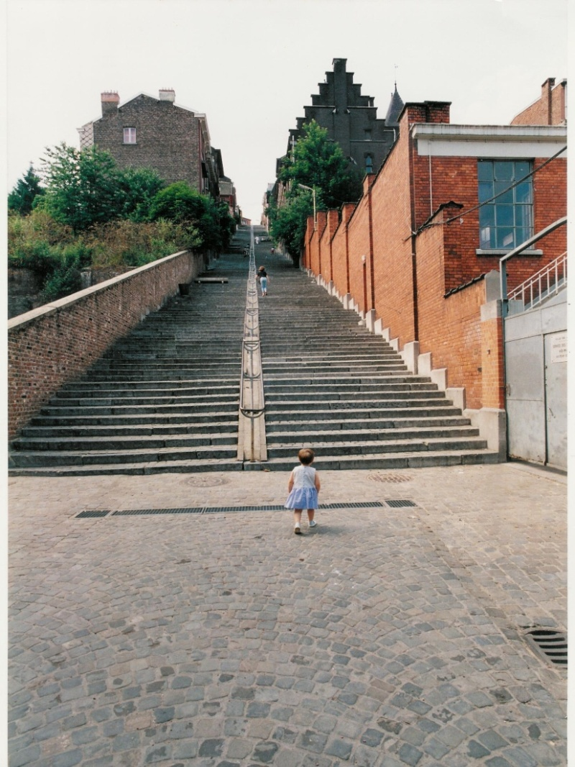Guidance in compulsory education and lifelong guidance

The pupil, the student has to be in the heart of his own guidance process.

The guidance system addressing the pupils and students has to be considered as a support for a continuous process. This implies particular attention to the transition periods.

It is also necessary to prepare the access to the profession at school or at the university to make the graduate, the qualified capable to integrate in working life. This implies a good knowledge of the world of work and a mutual trust between the guidance specialists in and outside of the educational system.

A guidance process before the end of secondary education.

The following phases are necessary for each individual:

* Information
* Self-knowledge, fields of interest
* Contact with the world of work
* Preparation to higher education approach (options, required conditions)
* Raising awareness of lifelong learning

The guidance process implies a process based on duration, a progressive construction supported collectively and with individual phases if necessary. The guidance process implies the existence within the school, of persons - a team if possible- who have developed a coherent and concerted methodology and who have the appropriate skills in this field. Training and updated tools are essential as well as a recognition of the work carried out in the field of these activities.

Some other recommendations from the CEF.

In a perspective of lifelong learning, the work carried out within the framework of guidance in the classroom has to inform more youngsters about the possibilities offered by adult education and training.

An ‘occupation’ approach should, in a general way, enable to motivate the pupils and to take into account their choice in the development of a personal project, without wanting to push the young person too early to make a choice determinant for his studies and his life. Too many pupils are educated in a context in which professional insertion is not considered to be a priority or even to be desirable.

Initial education as well as continuous training should be organised to guarantee a professionalization of people in charge of information and guidance.

And finally, the CEF insists on the necessary networking: all the professionals in the field of guidance can benefit from the knowledge and skills from others, sharing tools, values and objectives.

CHALLENGES AND NEW CONCEPTS FOR LIFELONG GUIDANCE. PRACTICE AND POLICY DEVELOPMENT.

*Dr Raimo Vuorinen, Ph.D., is Coordinator of the European Lifelong Guidance Policy Network at the Finnish Institute for Educational Research, University of Jyväskylä, Finland.*

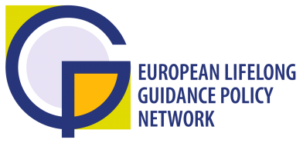

Context

Over the present decade, the role of guidance has been gradually taken into account in the European policies, in the sector of education & training as well as in the employment area. The 2004 Resolution on Lifelong Guidance[1] during the Irish EU Presidency was the first major EU level policy document explicitly on guidance and invited Member States to "seek to ensure effective co-operation and co-ordination between providers of guidance at national, regional and local levels in the provision of guidance services." The resolution invites “to build on and adapt existing structures and activities (networks, work groups, programmes) related to the implementation of the resolution priorities. Within this Resolution Lifelong Guidance refers to services and activities intended to assist individuals of any age and at any point throughout their lives to make educational, training and occupational choices and to manage their careers. Such services may be found in schools, universities and colleges, in training institutions, in public employment services, in the workplace, in the voluntary or community sector and in the private sector.

The role of the Lifelong Guidance was strengthened and described in more detail in the EU Council Resolution on ‘Better Integrating Lifelong Guidance into Lifelong Learning Strategies’ passed in 2008 under the French EU Presidency.[2] The Resolution invited the Member States and the Commission, with their respective competences, *“to strengthen European co-operation on lifelong guidance provision, in particular through the ELGPN, with the support of the Lifelong Learning Programme, and in liaison with CEDEFOP”.* In particular, four tasks were specified:

*– “enable Member-States to share information on their policies and practices, and on their evaluation of both, so that each may benefit from the successes of others;*

*– monitor national and European implementation of activities in the four priority areas under this Resolution, using surveys, studies, reports, and peer learning activities including case studies and conferences at European level;*

*– endeavour to ensure that lifelong guidance is more consistent and more tightly dovetailed with the various European policy areas and in particular with those of employment and social inclusion;*

*– consider whether more evidence-based policy on guidance should be developed at European level.”*

The Annex to the Resolution specified four priority areas:

* *“encourage the lifelong acquisition of career management skills;*
* *facilitate access by all citizens to guidance services;*
* *develop quality assurance in guidance provision;*
* *encourage co-ordination and co-operation among the various national, regional and local stakeholders.”*

Recent progress in Lifelong Guidance policy development in the European Union

The ultimate aim of the 2004 and 2008 Resolutions is to provide better guidance services for citizens in Europe and also provide comparative data to support the policy development. According to Cedefop (2008) the Member States have reported positive progress on lifelong guidance policy development. This follow-up on the implementation of the 2004 Resolution shows that most of the progress has been achieved in developing the services which are visible for the citizens, for example new information portals, help lines and staff development programmes for the practitioners. These are very valuable features of lifelong guidance provision. However, some of the future challenges still relate to access in Lifelong guidance services. European citizens have not sufficient training to manage their individual learning paths. Their voice has not been heard enough when developing the services. They are confused if they cannot see co-operation and consistency between different services available. There are varieties among the competences of the professionals and non-professionals in charge of the services.

A key concern for policy makers is the use of existing funding available in a cost effective manner. Different ministries are aiming towards similar goals but using different terminology, such as active citizenship, social inclusion, retention, preventing social exclusion and dropoutism, smooth transition to the labour market etc. Often the programmes designed to meet the challenges are parallel and overlapping.

We have evidence that guidance has much to offer in meeting the previously mentioned challenges, for example in supporting transitions, and in helping citizens find and keep employment. Lifelong Guidance, as both a private and a public good, is therefore increasingly seen as an important service that needs to be offered in lifelong and life wide perspectives. We have to explore guidance from a wider paradigm.

The progress can be enhanced if governments invest in the systems that support consistent and coherent lifelong guidance policy development. These features are not visible to citizens, but have major implications on the quality and cost-effectiveness of the services. This approach requires close co-operation between different ministries in charge of guidance related policies as well as a solid evidence base.

Evolution of the ELGPN - Enhancing European co-operation by sharing experiences in good practices and policy development

At the end of 2005, about one year after adopting the Resolution, the Commission initiated a discussion with its Expert Group for Lifelong Guidance[3] on what would constitute a suitable mechanism to support the European Union lifelong guidance policy implementation at national level involving relevant ministries and other bodies responsible for education and labour-force issues.

The Finnish EU Presidency Conference on “Lifelong Guidance Policies and Systems: Building the stepping stones” (November 2006) workshop conclusions stressed that the fragility of lifelong guidance policies at national level called for a strong and stable mechanism at European level to encourage more sustainable development at national level and support both policy development and implementation. The Commission was willing to continue to assist the process, in particular with the help of Cedefop (European Centre for the development of vocational education and training), and could also offer financial support.

The European Lifelong Guidance Policy Network, ELGPN was established as a Member State driven network by a contract between the network coordinator and the Commission DG EAC in December 2007. During the initial phase 2007-2010 there are 26 member countries and three observers in the network.

The ultimate aim of the ELGPN is to provide added value to the participating countries for the development and implementation of their lifelong guidance policies, systems and services. This should benefit stakeholders, providers and users. Another added value is improved cooperation in lifelong guidance policy development between the Member States, European Commission and relevant bodies or networks at national, European or international level. At the national level the ELGPN promotes sharing of good practice in the development of national coordination mechanisms.

Membership of the network is open to each of the countries eligible for assistance under the European Union Lifelong Learning Programme 2007-2013. The participating countries have designated their representatives in the network. The working assumptions are that each national delegation will include both governmental and non-governmental representatives. Through appropriate liaison arrangements, the network ensures regular contact with other relevant bodies or networks at national, European or international level.

Because EU Member States are responsible for their own lifelong guidance policies and systems, the ELGPN promotes lifelong guidance particularly through the open method of coordination. The network members jointly identify and define the objectives to be achieved with the Council Resolution 2004 and other EU policy documents as a basis. The members stimulate innovation and convergence through peer learning and exchange of best practices. The ELGPN has agreed to focus on the following thematic activities:

* Career management skills
* Access, including APEL
* Co-operation and co-ordination mechanisms in guidance policy and systems development
* Quality assurance / Evidence-base for policy and systems development

Conclusions

At the beginning of 2010’s the EU is revising the key policy drivers in education and labour market policies. The Council conclusions of 12 May 2009 on a strategic framework for European co-operation in education and training (ET 2020)[4] identify the role of Lifelong Guidance in the objective 1 (‘Making lifelong learning and mobility a reality’). The “New Skills for New Jobs”[5] as a joint initiative by the DG EAC and the DG for Employment, Social Affairs and Equal Opportunities provides a more structured opportunity for the Member States to examine what Lifelong Guidance can do in support of matching skills and jobs from both individual and labour market perspectives, and how strategically to use existing labour market information from a guidance perspective.

The Commission issued on 24 November 2009 a public consultation document on ways of triggering economic dynamism through the EU 2020 Strategy. The consultation paper[6] sets out key policy areas helping to come out the current economic crisis. Among the three thematic objective Lifelong Guidance is not explicitely mentioned, but it is needed to reach the goals identified in these strategic priorities.

The implementation of the forthcoming policy priorities can be supported with structured co-operation between the Member States. The establishment of the ELGPN was an initiative by the EU Member States through the open method of coordination. Thus, the European Lifelong Guidance Policy Network consisting of individual national guidance forums is to be seen as a mechanism to promote cooperation at Member State level on lifelong guidance and to support establishment of national/regional structures in education and employment sectors. The ELGPN has also an interface with the parallel international collaborative projects on policy issues of mutual interest or in facilitating and promoting worldwide exchange of knowledge, experience and expertise in the field of policy and systems development.

From wider policy perspective the creation of the ELGPN is a conclusion to meet the challenges the policy makers meet in implementing the Lisbon strategies and the tools supporting the strategy (e.g. APEL, EQF and ECVET). On the national level the ELGPN supports policy makers who are looking for tools to support these national reforms. One of the future challenges is to explore the interface of guidance and flexicurity from this wider perspective.

**The Role of Guidance at Crucial Transition Moments**

ROUND TABLE WITH REPRESENTATIVES OF EU EDUCATION COUNCILS

# How can guidance, at different transition moments in education and life, empower learners to

# - manage their career paths and develop their competences in the context of a turbulent labour market?

- develop competences for personal development and active citizenship?

- manage a successful learning pathway rewarded with a qualification?

What does this mean for guidance policies, instruments and key players?

Guidance at crucial transition moments: early childhood and primary education

Roos Herpelinck, Vlor (Vlaamse Onderwijsraad)

Roos Herpelinck is a staff member of the Flemish Education Council (Belgium). She works for the EUNEC secretariat as an expert and is a member of the executive committee.

The perspective and the scope of this contribution on guidance during early childhood and primary education is a specific one. This contribution is focusing on early childhood. Because of the characteristics of these pupils, the concept of guidance is necessarily different from the perspective of insertion in labour market or lifelong learning.

Guidance: an inclusive and multilateral approach.

In Flanders, guidance and pupil counselling are integrated into one approach. Policy makers opted already in the sixties for an inclusive approach of guidance, certainly in compulsory education.

The following definition of guidance is different from the definition given by Dr Vuorinen, but linked to it:

“Guidance consists of an inclusive set of guidance and counselling activities, in order to support the personal, social and cultural development and participation of learners, both in school and in society, in the context of a learning environment, focused on the individual learner, his interaction with the school and/or the home environment, both in group and on individual basis.”

Guidance: four domains of counselling.

The Vlor identifies four domains of counselling:

* Guidance of the study career: to help pupils to make choices
* Counselling in case of learning difficulties and special needs
* Counselling concerning the development and well-being of learners: health, social and emotional well-being
* Support participation in education, especially for early childhood education and care: to stimulate youngsters to attend school on a regular basis

Partners in guidance.

School is in the first line, in the four domains; school has the first and major responsibility, but can be assisted by other actors.

An example of the integrated approach: stimulation of early childhood education through guidance.

Stimulation of early childhood education is a hot topic in Flanders, because of the strong focus on equity and on lifelong learning. We always had a very strong system of early childhood education. But the emphasis on equal opportunities and the international new stimuli put the issue once again on the policy agenda.

At the moment, in Flanders, there is a 97% attainment to early childhood education between 2,5 and 6 years; we are very proud of this attainment.

BUT, there is a clear difference between the ‘inscription’ in a school and the regular presence at school; the need for a policy of stimulation persists. In Flanders, there is a consensus to go for a policy of stimulation rather than towards an obligation, and thus a lowering of the age of compulsory education.

Moreover, there is a problem with the smooth transition from early childhood education to primary education. The problem has to do with

* the proficiency in the school language
* the general maturity
* speaking, language and development disorders

Stimuli for a regular attendance of Kindergarten are situated at three levels:

**At the level of the pupil:**

A presence of 2/3 of one year in a Dutch speaking school is required (220 days); if not, a language test will be organised by the counselling centre.

In the case of children who are not attending the Kindergarten, a visit of a social worker (coming from the welfare system, not from education) is organised.

**At the level of the school:**

The ‘Care+’ programme: extra money and extra staff for the participation of children at pre-primary level.

**At the level of the guidance centre:**

Testing (see language test above)

Support of Care+ at the system level

A link with a reform of special needs education, although this remains a difficult discussion.

The role of the Flemish Education Council as a platform of stakeholders.

There is confusion on the role of schools and the role of the centres for pupils’ counselling. The Vlor formulated recommendations to the government two years ago. The education council influenced the agenda setting and broadened the problem.

The Vlor organised a conference with the participation of ‘field workers’ from schools, guidance centres and welfare workers/health workers on the expectations and a common understanding of guidance. A broad spectrum of educationalists and welfare workers have been consulted.

The Vlor is now trying to translate the conclusions of the conference into a recommendation, offering a platform for common understanding between schools, guidance centres and welfare/health workers, at the level of the policy makers. The education council plays an important role in preparing a policy decision, and has special attention for the transversality of policy making.

Guidance through transition moments during secondary education (general and vocational)

# **Pilar Calero López, CEE (Consejo Escolar del Estado, Spain)**

*Pilar Calero López is Philologist, Education Inspector, School Council President of Castilla – La Mancha and Counsellor at the National School Council.*

In Spain, the Law concerning guidance came out in 2006, based on the guidelines of European education, in relation to educational policies searching quality and education services development. However, it is not easy to change suddenly an existing situation: maybe the content of the law goes further than what really happens in schools.

The Organic Law of Education (Ley Orgánica de Educación, LOE 2006) offers , at national level, the legal framework to provide and assure the right to education. The Autonomous  Communities will be able to regulate the adaptation of this Law to their territories.

The Spanish *education* system, set up in accordance with the values of the Constitution and based on the respect for the rights and liberties recognized therein, is inspired by the following principles:a) Quality *education* for all students, regardless of their condition and circumstances.b) Equity that guarantees equal opportunities, *education*al inclusion and non-discrimination and that acts as a compensating factor for the personal cultural, economic and social inequalities, with special emphasis on those derived from disabilities.c) The transmission and application of values that favour personal liberty, responsibility, democratic citizenship, solidarity, tolerance, equality, respect and justice and that also help to overcome any type of discrimination.

Guidance, a key factor in education

Guidance is defined as a key factor of quality and a means to achieve a whole education. All the students have the right to benefit from guidance. Guidance should not only improve the school results of the students, but should also benefit the student as persons.

Nowadays one of its main tasks is try to prevent students from giving up education and keep the early leavers within the system. Over thirty per cent of students leave school without a qualification, impoverishing their own lives and increasing the unemployed number. This fact is a good reason to focus guidance on developing their self-confidence and self-awareness. In a few words: help students to help themselves.

The underlying idea of guidance is the strong conviction that everybody is good at something. The sooner the education system knows what the student is good at, the better for him or her. It also means helping families and teachers to improve their educational practices, in order to give pupils the best education and counsel as possible.

Guidance departments in secondary schools

In secondary schools, there are specific departments for guidance. Each team is composed of four persons:

* a guidance professional
* three teachers specialized in the fields of science, socio-linguistics and technology. Usually other teachers in charge of students with special needs take part in this department.

The existence of these teams is not a consequence of the new Law. They existed before, but the way they work has changed. Before the Law of 2006, the whole team of four persons assumed the whole guidance activity. Now, we consider that every teacher has a part to take up in the guidance activity.

An important consequence of this approach is that all teachers, and especially when these teachers are at the same time tutors, have to be prepared. This is not an easy task. They need new methodologies; they really need to learn how to practice guidance in a better way.

It will certainly take some time before this new inclusive approach of guidance becomes effective, but the expectations are high: sharing tasks will make things better.

In Spain, there are seventeen Autonomous Communities and, most of them, have developed their own guidance system, trying to improve the common one but these changes happen, mainly in Primary schools.

Guidance is crucial in secondary schools

Guidance is crucial in secondary schools. Why?

• First of all, the students must choose optional subjects along the four years or courses, from twelve to sixteen years old.

• Secondly, those students who make a great effort but even though they can’t catch up with, may be advised to follow a special programme of curricular diversification.

• Thirdly, those who are in risk of becoming early leavers may be guided towards initial professional programs (Level I).

• And finally, the majority of them will finish their secondary studies and again make a choice either professional studies (second degree or level) or prep. university.

At the same time, several programmes to provide them support are offered.

If we agree that transition period are critical and key moments in guidance, we should pay special attention on how guidance should be done, the teaching methodologies appropriate for learning how not to discriminate, how to explore her or his own abilities, how to implement decisions and deal with their consequences.

Group dynamics, tutorial sessions, systematic counselling, debates and courses, any activities where families could take part.

Many secondary schools carry out guidance through a project in which they put together their tutorial working plan and the one for vocational and professional guidance.

Another aspect of inclusive guidance is the fact that all students need help and assistance to become real citizens, not only those who have problems during their school career.

It’s not easy for schools to take up this task alone. Schools should be able to share these tasks with

* Families: they have the experience of guidance during primary education, but are not used to guidance during secondary education.
* Society.

The new Law is now being implemented. A large debate is going on; counselling is being integrated systematically in schools. A next phase will be the evaluation one.

At this moment we can conclude that

* We must try to avoid the early giving up.
* We need more implication of families in school.
* We need to explore the methodologies for more active implication of the students.
* We need to convince all teachers that they must take up their part of guidance activities.

Anyway, we are confident that this work will be a success; of course we know it’s no small job but in such an important achievement we must say that the sooner we have the results the better.

Guidance and transitions in Portuguese schools

Professora Ana Maria Dias Bettencourt, Conselho Nacional de Educação

*Professora Ana Maria Bettencourt is the President of the Portuguese Council of Education.*

*She is Master in Psychology and Doctor in Educational Science. She is a professor in Educational Science and President of the Higher School of Education of Setúbal (initial and in-service teacher training).*

*She was a Member of the Portuguese Parliament(1991-1995) and adviser to the President of the Republic on Education (1996-2006). She has been a delegate to the Council of the International Bureau for Education of UNESCO since 1996.*

*Professora Bettencourt published in the field of educational policy, innovation and education, teacher training and participation of women in politics. She leads an action-research-training project in the context of a cooperation between the Higher School of Education of Setúbal and the Directorate – General of Innovation and Curriculum Development of the Ministry of Education). The aim of this project is to understand the obstacles to the learning process, to improve the level of pupil integration and to reduce unqualified dropout rates in compulsory education, thanks to innovative approaches.*

During the last five years, Portugal has made serious efforts in order to ensure that Portuguese youngsters can achieve higher school levels and professional qualifications. The recent decision that makes education compulsory up to the age of 18 is just the latest example.

A careful attention to those pupils with learning difficulties (during ISCED levels 1 and 2) and a closer look to their school pathways from very early stages, as well as the upgrade of the resources of all schools in deprived areas with low socio economic conditions, have promoted the diversification of educational supply and curriculum flexibility as incentives to ensure a better education for all.

In spite of the low attendance rates in secondary education (below EU average) at ISCED level 3, we have to recognize the remarkable progress achieved in terms of attendance in courses with double certification (educational and professional), hence reverting the previous dropout situation in the Portuguese system. Opening up the range of options in transition moments from primary education to secondary and then to higher education leads us to face new challenges, particularly in terms of school and vocational guidance and change of teaching practices, namely when considering the equity that an education system must guarantee.

Challenges for the Portuguese education system.

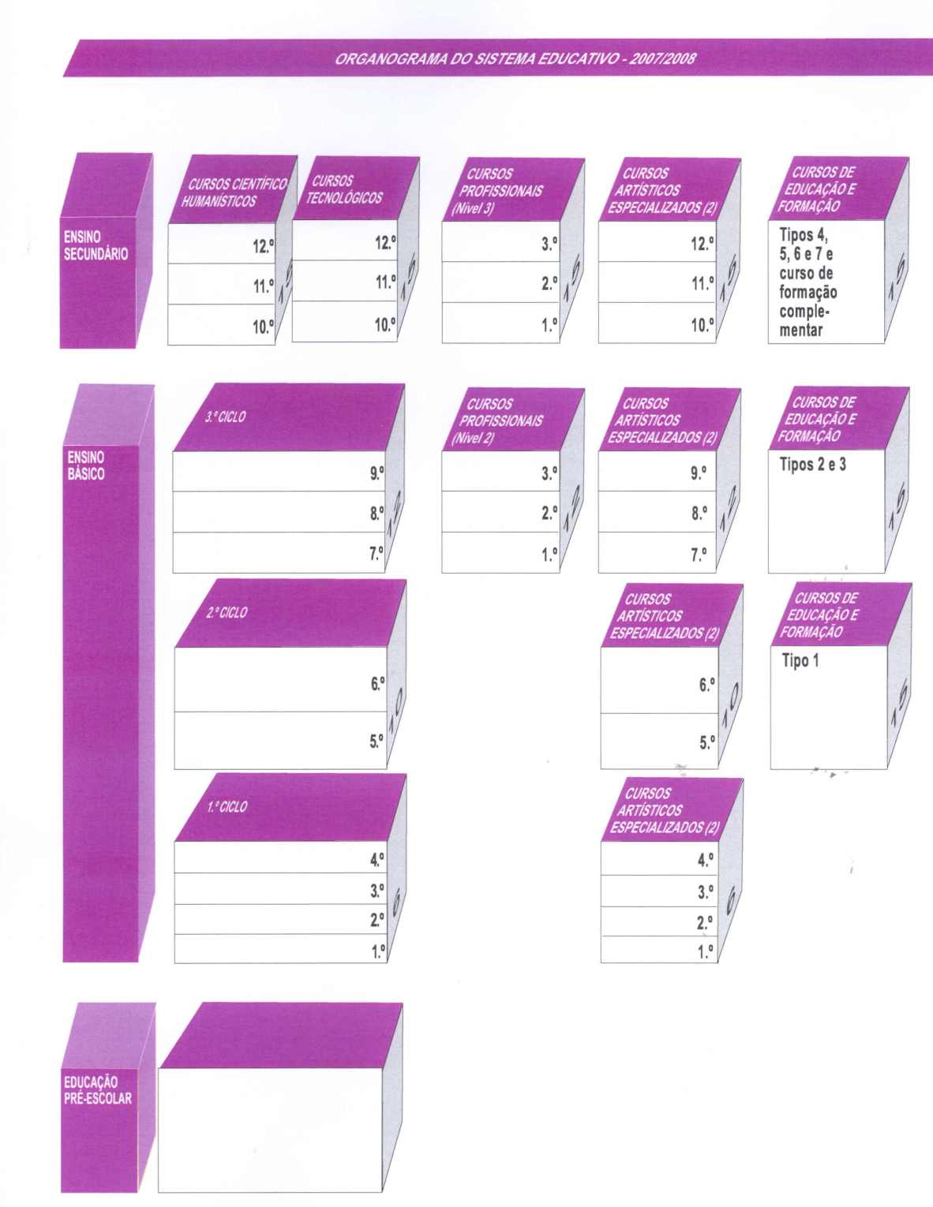The figure shows the organisation of the Portuguese education system, from pre-school education, through basic education towards secondary education.

Types 2 and 3

Type 1

Education and Training Courses

Types 4,5,6,7

Complementary Education Programme

Specialized Arts Education

Technological courses

Vocational Courses

1st cycle

2nd cycle

3th cycle

Secondary Education

Pre-School Education

Basic Education

Humanistic and Scientific courses

Nowadays the Portuguese education system faces three important challenges:

* to obtain higher qualifications
* to extend compulsory education up to the age of 18 (= 12 years of compulsory education)
* to avoid dropout and unqualified school leaving

In the tables we can read the evolution of the percentages of year repetition and dropout, and the percentage of secondary education attainment.

Percentages of grade repetition:

|  |  |  |  |  |  |  |  |  |  |  |  |  |
| --- | --- | --- | --- | --- | --- | --- | --- | --- | --- | --- | --- | --- |
| **Years**  **Levels** | 96/97 | 97/98 | 98/99 | 99/00 | 00/01 | 01/02 | 02/03 | 03/04 | 04/05 | 05/06 | 06/07 | 07/08 |
| **3th cycle** | 20,9 | 19,0 | 18,3 | 17,9 | 19,1 | 20,2 | 20,1 | 18,9 | 21,0 | 20,6 | 19,8 | 15,0 |
| **Secondary Education** | 36,4 | 36,1 | 36,7 | 37,5 | 40,1 | 38,3 | 34,3 | 34,8 | 33,2 | 32,1 | 26,1 | 22,3 |

Source: GEPE/ME/INE, I.P. (2009). 50 Anos de Estatísticas da Educação – Volume I, Lisboa

Percentages of secondary education attainment:

|  |  |  |  |  |  |  |  |  |  |  |  |  |
| --- | --- | --- | --- | --- | --- | --- | --- | --- | --- | --- | --- | --- |
| **Years**  **Levels** | 96/97 | 97/98 | 98/99 | 99/00 | 00/01 | 01/02 | 02/03 | 03/04 | 04/05 | 05/06 | 06/07 | 07/08 |
| **Secondary Education** | 63,6 | 63,9 | 63,3 | 62,5 | 59,9 | 61,7 | 65,7 | 65,2 | 66,8 | 67,9 | 73,9 | 77,7 |

Source: GEPE/ME/INE, I.P. (2009). 50 Anos de Estatísticas da Educação – Volume I, Lisboa

How to understand school failure?

Statistics prove that a lot of pupils of 13, 14 and 15 years old are not attending classes aimed at their age group. This is one of the major problems waiting to be urgently tackled: we need all pupils to be in classes at the level they belong to.

Another difficulty comes from a traditionally strong trend towards the prevalence of humanistic and scientific education with about 66% of the pupils enrolled in this sort of courses. Changes have been also occurring in this field. Nowadays about 50% of secondary education pupils are attending vocational courses with double certification (educational and professional).

On the other hand, with a view to understand the processes that lead to the production of dropout situations, school failure and indiscipline in post-primary basic education (from 5th to 9th grades) and identifying prevention factors, some case-studies have been carried out from 2006 to 2008 which comprised seven school groupings. Presently we have been focusing our attention on two of these groupings and one school particularly. This project follows an action-research-training methodology with a strong ethnographic dimension which even includes teacher coaching. Our main focus is pupils’ itineraries and the way problems are tackled in pupil assessment meetings.

Taking the case-studies as a basis, we can formulate the following conclusions:

* Teachers often regard learning difficulties as the problem of the pupils and the families, and not as a school problem. They don’t identify themselves with the problem, so they don’t assume the responsibility to solve it.
* Class committees (consisting of the teachers that teach in a given class and the respective class director) often concentrate on the diagnostic of the problem of the pupils, and don’t further reflect on pedagogical strategies to solve these problems.
* Any observation of a day at school shows that pupils don’t work a lot at school though everybody knows a lot of pupils have little support at home.
* Very often, school is perceived to be a place to listen whereas home is held to be a place where you work.

Adopted solutions.

At national level, some measures have been recently taken which promote equity and open up to more inclusive practices.

At school course level, the following strategies have been adopted:

* Alternative pathways, easier programmes, better tutoring to the pupils.
* Education and training programmes for pupils of over 15 years, so that they can complete present compulsory education (1st to 9th grades).
* Expansion of the offer of vocational education in secondary education.

Changes at curriculum level:

* A curriculum based on competences
* Transversal areas: guided study, projects, citizenship education.

Innovative projects; pedagogic interventions:

The *Educational Territories of Priority Intervention* (TEIPs), which first appeared in the school year 1996/1997, aim at developing better learning conditions for students. The TEIPs developed as a result of policies introduced to support underprivileged populations. They comprise groups of schools where projects are developed to improve education standards and to promote innovation. Schools belonging to one of these *Territories* should develop joint-work to devise a common educational project where the participation of teachers, pupils, Parents' Associations, the local government and cultural and recreational associations should be included. This educational project should is also supposed to stick to certain pedagogical priorities, such as:

* creating conditions to promote pupil achievement;
* defining the training needs of teachers and other staff members, as well as the needs of the community;
* promoting a close articulation with the local community;
* operating integrated resource management; and
* developing educational, cultural, sports and free-time activities.

TEIPs are based on positive discrimination.

Having the school project as a basis, the Ministry of Education celebrates a contract with each one of these school-groupings with the major aim to reduce dropout and failure rates. These contracts include some of the following resources:

* Support: study support for mathematics, Portuguese language, second language
* Psychological and educational support, guidance
* Support for the pupil and the family
* Partnerships with other sectors (city, school, health, social security)
* Mediators
* Study of school failure and regulation
* “Security at School Programme”
* Training programmes for school leaders and teachers
* Cultural programmes: Excellence projects are trying to transform ghettos.

Recommendations from case-studies

The following picture illustrates one particular excellence project precisely developed in one of these TEIPs included in the above mentioned case-studies. At stake is a particular school located in a region traditionally regarded as at-risk, inhabited by a high percentage of immigrants. 50% of this school population (530 pupils) coming from poor or very poor families, some of them even suffering from hunger.

In this case, the school orchestra is an initiative that strengthens the link between parents and the school world. Parents come to concerts at school, meet the school staff and other parents: social capital development is this way put in place.

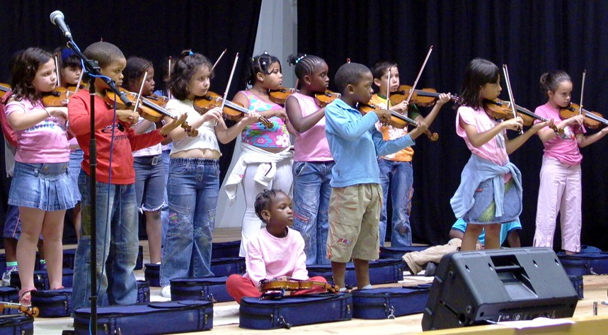

From the studies carried out in these Educational Territories some recommendations can be drawn at several levels.

In the field of Teacher training the importance of curriculum projects at class level should be emphasised though obviously individual pupils can never be forgotten. Here again stereotypes should be made the object of deeper reflection and particularly those related to year repetition. In fact, if a pupil does not succeed, that may be for countless reasons waiting to be identified and addressed. Regarding the pupil as simply lazy or adverse to work should be no longer acceptable.

Several pedagogical innovations should be introduced which have proved to promote pupil achievement.

* Evolution of the mandate of the class committees and of the class director in the sense of assuming greater responsibility for pupils’ learning.
* Practices of differentiation.
* Intervention at the first sign of difficulty.
* Organisation of student councils at class level.
* Tutoring.
* Collaboration among teams of teachers with a view to enhance pupil achievement.
* Reorganisation of the school day: individual work plans, more autonomy for the pupil, pupils’ responsibility for their own study
* Support classes.
* Projects linking education to the world of work.

In the field of school empowerment, the role and the mandate of schools have to be reconsidered, and guidance has an important role to be played:

* Greater responsibility of the pedagogic team of teachers for pupils’ success.
* Availability of school psychologists.
* Head teachers being the team leaders of all teachers.
* Tighter links between school and the labour world.
* Competency-based education at school and throughout life.

Recent developments in the schools comprised in the project

From 2008-2009 onwards some changes have been introduced in the schools monitored within the project which lead to a more ‘autonomous’ school and to more autonomous children.

* Autonomous work: more time will be dedicated to self regulated and guided work at school.
* There will be two moments of autonomous work at school per day.
* The pupils will be more responsible for their learning process: they are supposed to fulfil an individual work plan.
* 90 minutes per week will be destined to communication; 90 minutes per week will be dedicated to self regulated learning and work.

Transition moments towards tertiary education and VET

Mal Davies

*Mal Davies is Chairperson of the General Teaching Council for Wales*

The background to the educational setting in which Wales finds itself today.

The Welsh Assembly Government has devolved responsibility for education in Wales for just over 10 years.

* The Secondary School Curriculum had been dominated by the Universities
* While GCSE’s and A Levels provided a good standard they are not appropriate courses for all pupils
* The over academic diet failed to motivate all pupils
* The system did not provide employers with appropriately skilled employees

Recent developments in Wales have been shaped by the Welsh Assembly Governments Document “The Learning Country”. This document has resulted in almost a decade of WAG policy and strategy that has been moving steadily in a consistent direction aiming for a distinct educational system for Wales, which meets the needs of Wales and its young people and gives parity between academic and vocational education.

The goal which the WAG set itself for education was that “95% of young people by the age of 25 will be ready for high skilled employment or higher education by 2015”. To achieve this it was claimed that nothing less than a thorough transformation was needed through its “Learning Pathways Programme”.

Learning Pathways in generic terms are the learning experiences of each individual 14 – 19 year old and involve an educational entitlement. They also include a balance of formal and informal learning, wider choice, flexibility and a learning core for 14 – 19 year olds. The pathway also provides a unique blend of support to meet the learner’s needs.

The 6 key elements of 14 – 19 Learning Pathways

INDIVIDUAL LEARNING PATHWAY: Individually tailored Learning Pathway (which recognizes statutory requirements) leading to approved qualifications and awards of credit, appropriate learning at the right level(s) and at the right time to meet the learner’s needs, aptitudes and interests and running from 14 – 19 and beyond.

WIDER CHOICE AND FLEXIBILITY: Wider choice of relevant options from a range of domains with greater flexibility and an enhanced choice of vocational courses.

THE LEARNING CORE: Wider learning consisting of the skills, knowledge, understanding, values and experiences that all 14 – 19 year olds will need, whatever their Learning Pathway to prepare them for a successful adult life.

LEARNING COACH: Entitlement to learning support – the opportunity to provide good quality feedback on progress, discuss learning and progress on a regular basis.

PERSONAL SUPPORT: Access to personal support when needed through self-referral or by agreement with learner, referral by someone else.

CAREERS ADVICE AND GUIDANCE: Impartial careers advice and guidance to inform the individual’s Learning Pathway choices.

‘The Learning and Skills Measure’ which was introduced in 2008 promoted collaboration and planning between institutions, indicating that no school or college should work on its own. This strategy was targeted at ensuring all pupils had access to all courses on offer in local institutions. Guidance was given regarding the number and type of courses which should be on offer to all pupils by September 2009.

The Learning and Skills Measure

* The right for 14 – 19 learners to select courses of study from a Local Area Curriculum (LAC).
* The Minister will specify the number of courses in the LAC, the proportion of vocational courses and the range of domains to be covered. Currently 30 courses with at least 5 being of a vocational nature.
* A duty upon Heads, Principles, Governing Bodies and the LA to plan collaboratively for the LAC in order to meet the minimum requirement and maximise the availability of course.
* Specifies the grounds upon which a Head may decide not to allow an entitlement.
* Specifies the grounds upon which a Head may withdraw an entitlement from a learner.
* Provides for an appeals process for the decisions referred to above.
* Appeals process – in the first instance WAG has decided to opt for an informal process and see how this operates. Guidance will be issued soon around this and only if it appears that an informal process doesn’t work will WAG go down the route of a formal appeals process.
* Not to allow an entitlement – main grounds are clashes in options blocks, insufficient take-up so course not viable; course inappropriate for young person in relation to their abilities.
* Withdraw an entitlement – main grounds are linked to Health and Safety and behaviour of young person.
* The Minister can issue guidance and / or instruct in relation to joint working, co-operation and collaboration.
* Guidance to the Learner about the offer in the Local Area Curriculum should be impartial and be promoting the Learner’s best interest.
* Local Authorities are to promote the access and availability of Welsh medium courses.
* Requires that a range of Learner support services be available to meet the needs of learners.

Currently schools are working to harmonize timetables, reaching agreement on common value-added assessment systems, developing a common quality assessment system, sharing data and contributing to the area self-assessment review.

All institutions are charged with the responsibility to ensure all learners enjoy coordinated co-operative provision focused on the learners needs. To secure these desirable aims schools and colleges are moving towards a federated system of governance to ensure equal access for all learners.

Transitions from school to work. The Czech example.

Jaromír Coufalík and Jana Váňová

Jaromír Coufalík has been working for 28 years in the National Institute of Vocational Education and Training in Prague as researcher and project manager (curricula design, monitoring, analysis and evaluation of vocational training systems and practices, employability of young people, proposing new concepts of vocational education and training). He was advisor to the Minister of Economy in the field of apprenticeships training. Now he works in the National Training Fund as a consultant (administration of the Leonardo da Vinci programme in the Czech Republic, involvement in innovative training and employment support projects). He is a former member of EC working groups dealing with quality of education and innovation of vocational education and training.

Jana Váňová*started her career in 1988 at the Ministry of Labour and Social Affairs (MoLSA) of the Czech Republic. She was involved in the preparation of the European Social Fund and the EC initiative EQUAL. She was responsible for the HRD Programme Document. Later she worked within the area of cross border labour market co-operation projects: Austria-Czech Republic, Austria-Slovak Republic, developing comparative analyses of ESF implementation systems in 4 new Member States: Czech Republic, Slovak Republic, Hungary and Slovenia, responsible for INTERREG III A project financed by the European Commission and the Ministry of Economy and Labour in Austria. She coordinated activities in the framework of the Mutual Learning Programme for the employment area. In 2006 she prepared the full version of the Programme Document of the Operational Programme Education for the Competitiveness for the Ministry of Education and she contributed to the Operational Programme Human Resources and Employment of the Ministry of Social Affairs and Employment. She is now working with the National Training Fund as a consultant for the education and employment policy*.

This contribution is organised along three strands. First of all, the European context in the field of transition from youngsters from the sector of education to the real world of work is set. Next, the contribution focuses at the situation in the Czech Republic. And thirdly, information is given on the concrete instruments and key players of guidance, on examples of good practice and on the weaknesses of the guidance system.

Transition from school to work in the EU.

More than ten years ago, in 1997, the Czech Education Council was involved in an OECD project : ‘The transition from Initial Education to Working Life’. As a conclusion of this project, several important factors influencing this transition have been identified:

* The school system, e.g. the duration of the school attendance (the age), the proportion between general and vocational education. The Czech Republic is an exception in this field, with a high proportion of young people in vocational education.
* The contacts with the world of work during education (practical training).
* Teachers’ knowledge of the labour market.
* Teachers’ experience from the world of work.
* Career guidance opportunities.

**Unemployment rate of young people.**

According to Eurostat, the employment rate, in 2007, of young people under 25 years in the EU countries varies between 5.4 % (in the Netherlands) and 24.6 % (in Spain). Percentages are diverse: in Hungary, Sweden and Slovakia, there is an unemployment rate of over 20%; in Austria, Denmark and Norway, the percentages are under 8%.

The Czech Republic, as well as Germany, Estonia and Slovenia are situated somewhere in the middle: an unemployment rate of about 10% of young people under 25 years.

The unemployment rate of young people is higher than the average unemployment rate in Europe. For instance, in Germany, Spain and Slovakia the percentage of unemployed youngsters is between 1x and 2.5x the average unemployment percentage; in France, Denmark, Sweden, Belgium and Hungary it is between 3 and 5 times as high.

The numbers of unemployed young people are increasing. The forecast is not positive at all, as we deal with the consequences of the financial and economic crisis: ILO (the International Labour Organisation) foresees an unemployment rate of 25% of young people in Europe in 2010.

It is necessary to do something about this negative evolution. Guidance policy can contribute to the solution.

The situation in the Czech Republic.

Guidance in the Czech Republic focuses on graduates of upper secondary education. With about 80.000 graduates, this is the largest group. Guidance also focuses on graduates of Vocational Education and Training: in the Czech Republic, they represent about 80% of upper secondary education.

Guidance policies are based on data from regular surveys.

A first survey tries to find out through **which channels** young graduates find a job.

* 37% through help of parents, friends
* 22% through a visit of the firm
* 16% through internet
* 7% through practical training

The positive news is that about 80% of the graduates found a job easily or rather easily.

Another important conclusion of this survey is that there is still room for guidance. The majority of the graduates found a job through direct contacts, rather by chance. In the Czech Republic there is still space to work on guidance; guidance has a role to play.

Another survey examines **the satisfaction** of youngsters with their job. Again, the conclusions are positive: about 75% is satisfied with the position and with the conditions; about 54% is satisfied with the salary. From the perspective of guidance, it is interesting to see that about one third of the youngsters works in another sector than what they graduated for.

The figure below illustrates that the unemployment rate of graduates depends on their level of education. In 2009, the percentage of unemployed youngsters with university education is 3,10 %, which is considerably lower than the number of unemployed youngsters after only apprentice training: 13.40 %.

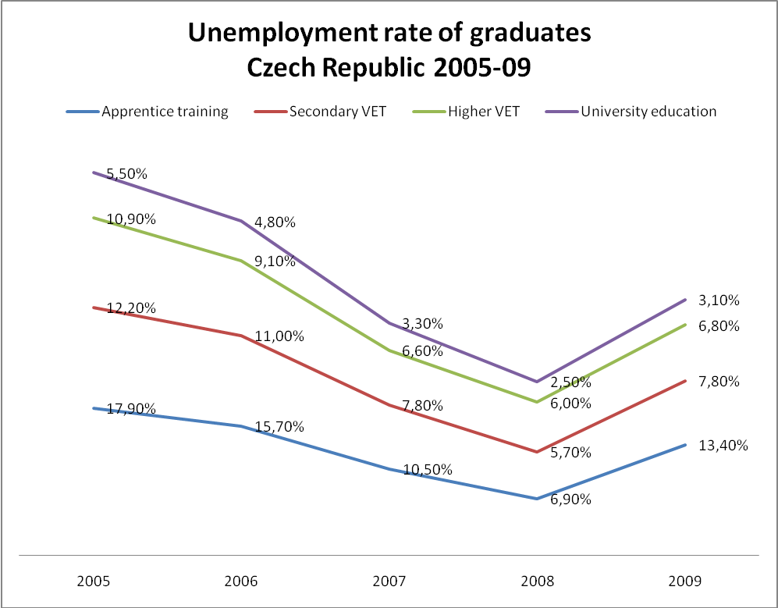

Guidance instruments and players

When young people enter the labour market, they unfortunately suffer from an important disadvantage: their lack of practical experience.

Several specific programmes for young graduates have been implemented in the Czech Republic. Concrete examples of specific programmes including training courses :

* *First opportunity*: individual guidance, co-financing of jobs for graduates
* *Start*
* *First job*
* *We help you to begin*
* *Practice – the way to employment*

These programmes are implemented by 77 regional Labour Offices: one Labour Office covers an area with approximately 130.000 inhabitants.

It is important to see that, within every Labour Office, there is a guidance department. These departments deal with unemployed people at all ages, but also specifically with unemployed youngsters. The guidance departments of the Labour Offices cooperate closely with the schools: this cooperation is extremely important for guidance in the Czech Republic. In almost all countries, guidance professionals work within the sector of Education, and also within the sector of Labour; guidance is provided at schools by professionals, so called counsellors: there are counsellors at primary and at secondary schools and counselling centres at universities. We have identified a weakness of this system: counselling at schools deals mainly with learning problems, not with the so called career guidance, with jobs for graduates, with information on the world of work.

Another instrument is the school curriculum.

In the Czech Republic there are framework programmes: several groups of themes, of skills and knowledge are obligatory for all types of secondary schools. One specific obligatory theme is ‘Man and World of Work’. The aim of this specific theme is to make entering the labour market easier. Concrete examples of content of these theme are, for example: how to search information on the labour market, self-presentation, writing a curriculum vitae, how to prepare a recruitment interview.

Finally, there is another very specific instrument: the ISA information system. It is the result of an European Social Fund (ESF) project in the Czech Republic, implemented in cooperation with the Ministry of Education and the National Institute for Vocational Education and Training. The information is available to the public at [www.infoabsolvent.cz](http://www.infoabsolvent.cz).

The Information System has four sections:

* Choice of schools and branches
* School graduates and labour market
* Guide of occupations
* Learning problems

Recent publications linked to the subject of guidance in the Czech Republic:

* *Unemployment of graduates of secondary and higher education.*
* *School graduates at labour market.*
* *Views of Labour Office professionals on the school graduates.*
* *Successfulness of entering the labour market.*

Conclusions

These conclusions are certainly applicable for the specific situation in the Czech Republic, but can probably be extended to other European countries:

The involvement of Public Employment Services in guidance activities contributes to a smooth transition from school to work.

Cooperation between counsellors in the education sector and in the public employment services is a key factor.

There is a lack of career guidance at schools.

Schools need information on the labour market.

INNOVATIVE PRACTICES IN THE FIELD OF GUIDANCE IN HUNGARY

Borbely Pecze Tibor Bors

*Tibor Bors Borbely is an advisor of the Hungarian Public Employment Service – National Employment and Social Office, Directorate of Education and Employment. He earned his undergraduate degree on employment and career counselling (1998), and MA from social policy (2001). Presently he is a doctorate student at the U. of ELTE, Budapest, Faculty of Psychology and Pedagogy. He is writing his thesis on teachers’ preparedness for LLG. He started his career as an employment counsellor, since the last five years has been working at national and European policy levels. He is a member of the European Employment Observatory MISEP network (2004); also national correspondent of the European Lifelong Guidance Policy Network (2007). Founder of the Hungarian National LL Guidance Policy Council (January 2008). His most recent works were:*

*-         The concept of competence in vocational education and employment policy [Munkaügyi Szemle, Vol.2006. No.5. pp.22-26.]*

*-         Coordination of 10 ESF financed research programme on demand and supply in the Hungarian labour market 2004-2008 [*[*www.employmentpolicy.hu*](http://www.employmentpolicy.hu/)*]*

Background

The Hungarian government defined its strategic goals and objectives for the 2007-2013 budgetary period in the New Hungary Development Plan. Within the Social Renewal Operative Programme (Hungarian abbreviation: TAMOP) it had delegated the development and the promotion of the national lifelong guidance network to the National Employment and Social Office (Foglalkoztatási és Szociális Hivatal, abbreviation: FSZH), which is the coordinating body of the Hungarian public employment service. The detailed planning of the OP started in 2007 and the elaboration of the final contractual version lasted until October 2008.

The commitment of the policy makers and other stakeholders of the project was marked by the establishment of the National LLG Council in January 2008. It works closely together with the other members of the ELGPN network as well as with the national policy makers. The 13-member council provides a stable professional background for the planning, implementation and promotion of the OP in national and international levels, according to the latest ILO and OECD guidelines.

OP data

The implementation of the first action plan of the OP takes place between 22 September 2008 and 21 September 2010. The budget of the national programme is HUF 2.08 Billion, approximately EUR 7.3 Million.

Main objectives

The main objective of the project is to develop the basis of a uniform guidance system that is equally available for all users in all situations during their student and professional life. Thus the development of an effective national lifelong guidance system is indispensable for the realisation of the lifelong learning services.

Within the Hungarian setting, this goal can be achieved by the revitalisation of the network of career guidance professionals by hiring new staff, providing up-to-date professional tools and materials and creating a strong cooperation within the network.

By supporting the professionals and developing online self-information tools, the OP seeks to increase customer awareness and satisfaction of the LLG services provided within the network of the PES (Public Employment Service).

Target groups

As the first two years of the project are planned to establish a strong professional base for the service provision within and outside the network of the PES, the main target group consists of the guidance professionals actually working on the field (pedagogues, education and employment counsellors, etc.). Currently, they receive little professional support, and their training possibilities are limited, which leads to little motivation from their part.

The project was planned in a sector neutral way, so we would like to involve professionals from various fields from governmental bodies and NGOs as well.

The secondary target group is made up by all the users of the guidance services, who will get a better, more efficient service due to the trainings and the new tools of the professionals.

Main activities of the OP

The implementation of the operative programme is based on four main areas, as described in the following figure.

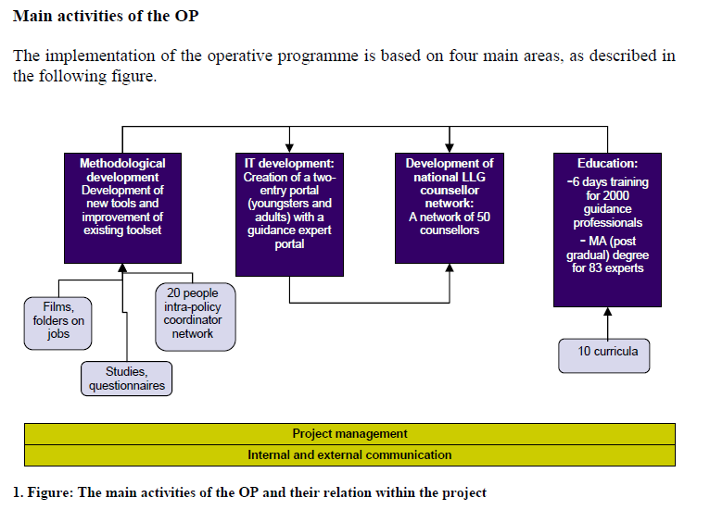

1. **Methodological development**

As described above, the main goal of the project is to develop and provide an up-to-date toolset to the professionals in the field of career guidance. Currently, there are several films and files giving a detailed, interactive demonstration of different jobs that are available for the professionals and the public. The project will finance the enlargement of the available selection with about 150 pieces as well as the renewal of the older versions. Also, several studies and questionnaires will be prepared, that will be published for the professionals.

The establishment of a network of 20 coordinators between the project and other interested parties (employment offices, schools, higher education institutions, social institutions, NGOs) will significantly promote the knowledge on the project.

1. **IT development**

The IT development part of the OP seeks to set the basis of the virtual labour market services in Hungary. It aims to create a two-entry (for younger users mostly in the education system and for older users mostly looking for career counselling) homepage on the basis of the existing guidance portal of the PES. The development seeks to reach external databases on updated educational and labour market information in order to offer integrated information in a user-friendly way. The webpage would also offer a portal for the career guidance professionals, where they could reach all the information and tools regarding the project. It also helps creating a closely linked network within the professionals of the field.

1. **Development of the national LLG counsellor network**

As described above, the currently provided career guidance services are highly fragmented and differ in quality and availability in Hungary. The operative programme would like to set a strong basis of service provision on a national level by employing 50 guidance professionals. They would create strong, independent network of professionals who provide services for all citizens free of charge. The counsellor network is expected to work closely together with the other entities of the PES and other service providers, thus providing a wide range of services. The network of the counsellors is scattered around the country to provide easy access for users.

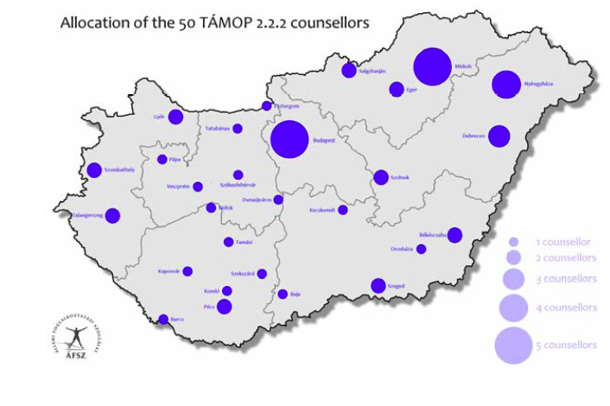

1. **Education**

As a long term dedication towards the set-up of a highly trained career guidance network the project finances the post-gradual (master’s level) education of 83 professionals in 2 universities. After obtaining their degree, the programme obliges them to work on the field for a period of time.

The programme also seeks to increase the level of knowledge of professionals already in the field from various sectors and entities (teachers, social workers etc.). This is why it provides a 2x3 days training programme for 2 000 people, with all their costs covered. The training programmes are offered in several locations nationally, to facilitate easy reach and increase the possibility of participation.

The topics for the 2,000 professional’s training that are also being developed during the programme are the following:

1. The importance of career knowledge

2. The role of self-knowledge in building one’s career

3. EU competencies

4. The importance and usage of Europass - studying and working in the EU

5. Methods of informal job search, from job to job

6. Use of new possibilities (internet, television)

7. Special situations (Roma, handicapped people, etc)

8. What is work, what are the atypical working types

9. What does LLG mean and how does it work

10. What organisations can help you – service providers within the field of career guidance and orientation

**The Role of Guidance and the learning pathways of vulnerable learners**

How can guidance support the learning pathways, the well-being and the school success of youngsters at risk of unqualified school leaving and of low achievers?

CONCLUSIONS OF THE WORKSHOP

*Mária Szabóné Pákozdi*

What aspects and elements does guidance need to involve? Participants at the workshop added some general principles and then focused on what the Councils can actually initiate.

Guidance for pupils and students must be present on several level

Guidance is not only relevant for the individual, but for the school and the local community as well. Guidance also has a role on a professional level. We collected the following functions, tasks of guidance to each level.

**The level of the individual (i.e. the pupil/student):**

Guidance

* supports the personal development and the formulation of a positive self-image from a very early age so that the student has an active role in shaping his own career and life, becomes an autonomous citizen, who takes responsibility for his development,
* focuses on key life skills, whose improvement must be maintained in whatever learning path the student chooses,
* creates possibilities for the validation of non-formal and informal learning,
* broadens the horizon of students and their families, so that they become aware of all possibilities both in education and in the world of work.

**The level of the school:**

Guidance

* supports the involvement of schools on several levels: the training of staff, the work of guidance professionals at schools, the new approach to learning/teaching and curriculum,
* may not be able to reform the educational system but supports a new approach to learning which focuses on students’ various strengths rather than weaknesses (Multiple Intelligences), the development of responsible, autonomous learners, the raising of student motivation by relevant content and form,
* thus it needs to get involved in curriculum design
* and training of teachers and school staff so that teachers are capable of detecting problems and can get help locally. Teachers and school staff are the first professionals who can assist the orientation of a student and his parents through everyday contact.

**The level of the community and society:**

Guidance

* can convey the expectations of the society towards the individual and the community,
* can contribute to the improvement of their self-image,
* needs to take part in the breakdown of social stereotypes (related to ethnicity or type of work, e.g. support the development of technical/vocational education in order to attract more applicants, or redirect families who are in cultural tension with the world of academia),
* needs to involve the local community in their work and nurture a good relationship with them,
* and create opportunities for students and their families to meet the world of work, to be introduced to jobs and work places.

**The level of the profession.**

Guidance

* must be professional and must take care of the education of professionals,
* offers continuous training to teachers and works in close cooperation with them,
* provides information in several fields, e.g. helps the individual to find out about themselves and improve their self-esteem, offers different opportunities and learning pathways,
* provides expert help to the individual to realize their aspirations and interest and helps to set goals and identify the skills they need to acquire to achieve their goals,
* and provides expert help especially in times of transition, reassures the individual that they are able to cope with the problems, gives them tools to redirect their career and life.

The participants of the workshop agreed on some principles:

Guidance …

* must be a continuous process starting as early as possible and reaching out as much as possible,
* needs a coherent system in society and should rely on networking,
* supports the free choice of the individual (that is, the solutions offered to the individual should not be made compulsory),
* needs to enhance cooperation with different stakeholders and needs to keep different directions in sight,
* has an influence not only on the individual but on the whole local community.

The Councils can initiate the following:

* the establishment of a system of guidance and networking,
* the breakdown of social stereotypes and the improvement of vocational/technical education,
* the involvement and cooperation of different stakeholders with a focus on the media (utilizing what it can offer),
* a marketing of Guidance for politicians („we must sell guidance to politicians”) with relevant statements and the presentation of good practices,
* emphasis of personal development in the whole school curriculum,
* establishment of quality standards for guidance, continuous training of teachers and the education of guidance professionals,
* harmonized development of policies together with practice.

How can guidance support the acquisition and maintenance of key competences, life skills and professional competences of vulnerable groups of adult learners (e.g. low qualified professionals, workers during a career reshuffle)?

CONCLUSIONS OF THE WORKSHOP

*Jean-Pierre Malarme*

The discussions during the workshop focused on four issues.

How to define the key concepts of this workshop?

Key competences: how to define them? What can a guidance professional do in order to improve them?

In this context, we think most of all about the competences of learning to learn, of language skills, also for unqualified people, and of interpersonal relationship.

‘Vulnerable groups’, and ‘adult learners’ are other key words for this workshop. Can the lack of key competences be linked to the different vulnerable groups of adult learners?

Participants at the workshop concluded that it is no use trying to identify different groups of vulnerable learners in relation to the key competences; every situation is individual, special. For instance: one cannot consider ‘migrants’ as one homogenous group; some migrants are high-skilled, others are not. The guidance professional has to adapt to the individual needs.

The perfect guidance professional. How to train him/her?

The perfect guidance professional should have the following characteristics:

* Ability to listen and to dialogue, in order to enhance the autonomy of the learner, his capacity to learn and to valorize his present skills, to focus on the strong points; define the objectives of learning together with the learner.
* Forget about uniformity: the guidance professional has to consider the learner as a subject and not an object, he has to observe how the learner deals with weaknesses and success, he has to evaluate the different types of support he can give to the learner.

The role and the qualities of a guidance professional should be:

* To help to define objectives
* To focus on strong points
* To guide in finding a solution
* To direct the process and not the person
* To network with other professionals
* To develop a reflective practice
* To be efficient
* To be supervised.

The work of guidance should support the acquisition of key competences: lacks of competences have to be identified and ways to remediate have to be proposed. The work of guidance cannot be simplified; diversity is a richness. Personal development, self efficiency and self esteem, have to be the final objective.

Critical conditions for efficient guidance for vulnerable learners

The guidance process can be represented as an interaction between three actors: the person, with his competences; the labour market and the guidance professional.

Labour market

The learner with his competences

Guidance Professional

The objective of the guidance professional is to help the learner to find his place in the labour market, if necessary through a learning process. But, the guidance professional has to respect the personality and the will of the individual learner. To conciliate both the wishes of the person and the needs of the labour market is not easy, especially not in a period of economic and financial crisis. That is exactly what social cohesion is about.

The role of the guidance professional, in this triangle, is to take into account the aspirations of the individual and the needs of the labour market, proposing a synthesis, always having social cohesion and integration in mind.

The critical conditions for this kind of work are support at a political level and the necessary investments, in other words a real lifelong learning guidance policy, allowing guidance professionals to network, to have a continuous in-service training and aiming the recognition of existing competences.

The role of education councils

The issue is larger than the field of education councils, because of the links with other policy domains (employment, professional training, ..). The situation is different according to the mandate and the missions of each education council. For instance, in the French Community of Belgium, the education council is working in the field of education and of vocational education and training. In this council, the work on guidance created a real dialogue between guidance professionals working in different sectors, who did not know each other before.

Networking in the field of guidance is very important, taking into account the particular mandates.

**Statements**

*EUNEC wants to disseminate these statements pro-actively towards the European Commission, the European Parliament, relevant DGs. EUNEC also wants to promote actions by its members at national/regional level. These critical remarks and statements offer an input for national advisory opinions of education councils. They should provide a significant input for reflection and action by relevant stakeholders in the field of education and training such as providers of education, teacher trade unions, social partners, experts in the field of education and training.*

Guidance, an emerging theme for EUNEC

Guidance has always been a part of the common understanding of EUNEC. In the past, EUNEC focused particularly on vulnerable learners and the effects of national and European policies on these target groups; EUNEC discussed EQF, ECVET and learning outcomes. Implicitly, guidance is the ‘fil rouge’ of the EUNEC statements on those subjects.

However, guidance is not a goal in itself; it is an instrument.

Drivers for the choice of guidance at this particular moment are

* The European education and training policy
* The lack of transparency of VET and education systems; the lack of smooth transitions
* The economic and social situation

Guidance, multiple perspectives

Guidance is at the crossroad of different perspectives and needs:

* The needs of society: welfare, social cohesion, health
* Equity and education goals: all pupils should leave schools qualified
* The needs of labour market, of career and life
* Guidance as a private good

Guidance is part of a global educational concept: participation of learners, participation of parents, active learning, learning outcomes,…

Guidance is part of the lifelong learning paradigm.

Guidance is a necessity, because of the fact that education systems became more flexible and diverse, dealing with diversity and equity, with inclusive education and special needs.

**Characteristics of guidance**

* Guidance is not a separate subject, but part of a cross curricular approach with links to the curriculum, the hidden curriculum, the school organisation, the learning pathways. There are also links to reflection, to self esteem, to soft goals in education.
* Guidance has to be a mainstream service; we should avoid the remedial image of guidance.
* Guidance at transition moments is crucial but guidance should be integrated in a lifelong continuous and trajectory approach, starting with early childhood.
* Guidance takes into account the context of the learner (family, social environment)
* In the field of guidance schools stand in the first line, but networking with other professional actors is crucial
* Guidance involves the responsibility of the user: every person has to manage his own career, make his own choices.

**Networking: a key word**

In the field of guidance, schools should be networking with the broader context: labour market, cultural background, sociography of the neighbourhood. There is a need for transversal policy lines at local/regional and at national level (actors, ministries).

Gaps between education and training levels and sectors should be closed.

Collaboration between multiple different actors should have a formal status and support structures in order to be able to build bridges and interfaces. An efficient guidance system needs to be transparent in order to improve common understanding.

**Enhancing the care taking capacity of schools**

The policy making capacity of school leadership has to be stressed: within this capacity a strand has to do with care, with managing arrangements for the pupils.

Vulnerable learners

Who are they?

* School repeaters
* Unqualified school leavers, drop outs
* Children with special needs
* Youngsters and adults suffering from critical conditions on the labour market, life crisis and reorientation, unemployment
* Youngsters and adults with insufficient level of literacy and numeracy

If guidance wants to be effective, it cannot be centred only on the vulnerable learner as an individual. It has to take into account the whole context: his family and social, economic and cultural background.

**Unqualified school leavers**

It is very important to work on a positive approach building self confidence. Guidance should convince people : ‘Society needs you; you are valuable to society’. On the other hand, there are links with active citizenship: people have to be willing to take that responsibility.

Guidance should offer second chances and flexible learning pathways, appealing to the diverse competences and talents of people.

During the trajectory guidance approach, the ‘salmon principle’, where people start at a lower level and are able to make their way up thanks to efforts and education, is more motivating than the ‘cascade principle’ (people starting on a high level, and having to take a step back if they don’t succeed).

The concept of ‘open school’ assures links with the neighbourhood and the environment.

The concept of ‘community schools’ assures a coordinated and diverse offer of learning pathways within a geographical area.

**Adult learners**

Guidance should help to maintain and enhance the eight key competences for adult learners. The approach will be flexible and personal, tailored to the needs of the adult learner.

Guidance has to be seen in a broad perspective: individual development, but also integration and citizenship, work perspective..

Critical conditions (level of the system)

Guidance has to be embedded in a global policy project, linking to different policy domains.

Professionalization is a key word: the importance of networking, of counselling, teachers’ experience of the labour market… The competences of the guidance professionals and of school leaders have to be stressed.

A careful implementation is an important part of the guidance policy.

The role of education councils

Education councils are organisations with room for dialogue. Ideas on education are discussed between different partners in education and society. Guidance is a transversal subject; education councils can play the role of boundary worker in this field.

Some of the EUNEC members worked on the subject of guidance playing an agenda setting role.

Education councils can identify the place of guidance in the own education system.

It is important to follow up the effectiveness of the new measures. One of the roles of education councils is to insist on the assessment of guidance measures.

**List of Participants**

Raimo Vuorinen European Lifelong Guidance Policy Network

Mia Douterlungne EUNEC General Secretary

Simone Barthel EUNEC President

Carine De Smet EUNEC Secretariat

Ana Maria Bettencourt Conselho Nacional de Educação, Portugal

Manuel Miguéns Conselho Nacional de Educação, Portugal

Teresa Gaspar Conselho Nacional de Educação, Portugal

José Manuel Canavarro Conselho Nacional de Educação, Portugal

Ann Demeulemeester Flemish Education Council (Vlor)

Roos Herpelinck Flemish Education Council (Vlor)

Dominique Lamotte Conseil de l’Education et de la Formation

Jean-Pierre Malarme Conseil de l’Education et de la Formation

Adrie Van der Rest Nederlandse Onderwijsraad

Emilija Sakadolskiene Lithuanian Education Council

Egle Pranckuniene Lithuanian Education Council

Gytautas Damijonaitis Lithuanian Education Council

Pillas Kyriacos Education Council Cyprus

Maria Markidou Education Council Cyprus

Carmen Maestro Consejo Escolar del Estado, Spain

Antonio Frias del Val Consejo Escolar del Estado, Spain

Pilar Calero López Consejo Escolar del Estado, Spain

Konrado Mugertza Urkidi Consejo Escolar del Estado, Spain

Natalia Cuddy Qualifications and Curriculum Development Agency, UK

Sue Barr Qualifications and Curriculum Development Agency, UK

Petri Pohjonen Finnish National Board of Education

Jugani Pirttiniemi Finnish National Board of Education

Reet Laja Estonian Education Forum

Heiki Koov Estonian Education Forum

Jana Váňová National Training Fund, Czech Republic

Jaromír Coufalík National Training Fund, Czech Republic

Jarmila Modrá National Training Fund, Czech Republic

Mal Davies General Teaching Council for Wales

Angela Jardine General Teaching Council for Wales

Anna Spokes General Teaching Council for Wales

Angela Soufli National Council of Education, Greece

Sharon Cousins Southern Education and Library Board, Northern Ireland

Marleen Brans Catholic University Louvain

Jan Van Damme Catholic University Louvain

Jonathan Gaskell Catholic University Louvain

Ilona Pokorna Education, Audiovisual and Culture Executive Agency

Tas Szebedy National Council of Public Education Hungary

Zoltán Loboda Hungarian Ministry of Culture and Education, member of the OECD Committee for Educational Policy

Borbély-Pecze Tibor Bors Hungarian National Employment Service

Zsuzsanna Farkas Hungarian Institute for Educational Research and Development and Teacher Training Centre

Laszlo Limbacher OECD coordinator

Gábor Boldizsar Hungarian Ministry Education and Culture

Sándor Brassói Hungarian Ministry Education and Culture

Judit Lannert Head of the TARKI-TUDOK Knowledge Management and Education Research Centre Inc.

Judit Fülöp Kádárné Hungarian Ministry Education and Culture

**Table of contents**

**INTRODUCTION 3**

**PROGRAMME 3**

**OPENING SESSION 7**

**The Hungarian Education System 7**

Tas Szebedy

**Let lifelong learning be underway 13**

Zoltán Loboda

**CHALLENGES AND NEW CONCEPTS FOR GUIDANCE 17**

**Lifelong counselling, guidance, information 17**

Simone Barthel

**Challenges and new concepts for lifelong guidance. Practice 23**

**and policy development**

Raimo Vuorinen

**THE ROLE OF GUIDANCE AT CRUCIAL TRANSITION MOMENTS 27**

**Early childhood and primary education 27**

Roos Herpelinck

**Secondary education (general and vocational) 33**

Pilar Calero López

Guidance and transitions in Portuguese Schools 37

Ana Maria Dias Bettencourt

Transition moments towards tertiary education and VET 45

Mal Davies

Transitions from school to work. The Czech example. 49

Jaromír Coufalík and Jana Váňová

Innovative practices in the field of guidance in Hungary 55

Borbely Pecze Tibor Bors

**THE ROLE OF GUIDANCE AND THE LEARNING PATHWAY OF VULNERABLE LEARNERS**

**Conclusions of the workshops 61**

**STATEMENTS 69**

**LIST OF PARTICIPANTS 73**

**TABLE OF CONTENT 77**

1. The Resolution of the Council and of the representatives of the European Union Member States meeting within the Council on Strengthening Policies, Systems and Practices in the field of Guidance throughout life in Europe (May 2004) <http://ec.europa.eu/education/policies/2010/doc/resolution2004_en.pdf>
2. http://register.consilium.europa.eu/pdf/en/08/st15/st15030.en08.pdf
3. To support policy development in guidance, in December 2002 the Commission created an Expert Group on lifelong guidance, including officials from education and labour ministries, representatives from the European social partners, as well as European and international bodies.
4. http://ec.europa.eu/education/lifelong-learning-policy/doc1120_en.htm
5. http://ec.europa.eu/social/main.jsp?catId=568&langId=en
6. Commission working document – consultation on the future ‘EU 2020’ strategy – Brussels 24.11.2009 – COM(2009)647 final