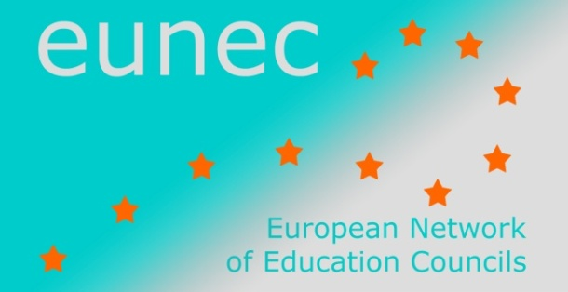 | 22 May 2013
 | EUN/EC/DOC/003

Main Policy Lines in Education and Training

December 2012 - May 2013

UNESCO

Youth and skills. Putting education to work.
Education for All Global Monitoring Report, UNESCO, October 2012
Many young people around the world — especially the disadvantaged — are leaving school without the skills they need to thrive in society and find decent jobs.
As well as thwarting young people’s hopes, these education failures are jeopardizing equitable economic growth and social cohesion, and preventing many countries from reaping the potential benefits of their growing youth populations.
The 2012 Education for All Global Monitoring Report examines how skills development programmes can be improved to boost young people’s opportunities for decent jobs and better lives.
Downlaod the report.

Transforming TVET: Building skills for work and life.
Report of the Third International Congress on Technical and Vocational Education and Training, Shanghai, 14-16 May 2012
The conference calls for a reform of TVET in an integrated manner, with policies and practices that are capable of responding effectively to the many economic, equity and transformational challenges. There is a need for a paradigm shift regarding skills development: the new paradigm of TVET should be conceived of in such a way that training systems can respond to the demands of the labour market, while at the same time helping citizens achieve skills required for work and for lifelong learning.
TVET reform therefore requires a new policy orientation. There is a trend towards enlarged stakeholder involvement that brings ministries, workers’ associations, civil society and industry together. In this context, the role of government is changing: while it used to be seen as a provider of TVET, it is now acting as a regulator, setting standards for training and employment. Effective stakeholder dialogue for curriculum development, program design, delivery and governance is needed.
Read more in the general report and the Shanghai consensus.

