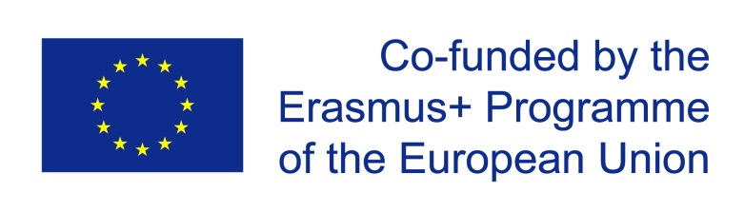

Main Policy Lines in Education and Training

(October 2014 – November 2014)
- OECD

Skills beyond school
November 2014
The results of this project have been presented to the EUNEC conference on ‘Bridging the transitions between education and the labour market’, Prague, 20-21 October 2014.
Skills beyond School is the OECD policy review of postsecondary vocational education and training. It looks at the preparation of younger people and adults for technical and professional jobs. Key policy challenges include responsiveness to labour market needs, alongside inclusion, access, career guidance, finance, governance, teaching quality, integration with workplace learning, articulation with other sectors of education, and qualifications and assessment. The review builds on the success of Learning for Jobs – which examined vocational education and training policy through 17 country reviews and a comparative report - and forms part of the horizontal OECD Skills Strategy linked to PIAAC and other initiatives across the OECD. It also draws on the OECD review of tertiary education.
This report synthesises the findings of the series of country reports done on skills beyond school.
- Chapter 1. The hidden world of professional education and training
- Chapter 2. Enhancing the profile of professional education and training
- Chapter 3. Three key elements of high-quality post-secondary programmes
- Chapter 4. Transparency in learning outcomes
- Chapter 5. Clearer pathways for learners
- Chapter 6. Key characteristics of effective vocational systems
The report, summary and policy recommendations at http://www.oecd.org/edu/skills-beyond-school/skills-beyond-schools-synthesis-report.htm

Education policy outlook

The OECD has published two new profiles of the Education Policy Outlook series: The Netherlands and Portugal. Already 15 profiles have been published.
Each profile reviews the current context and situation of the country’s education system and examines its challenges and policy responses according to 6 policy areas, building on the work of the OECD Directorate for Education and Skills.
www.oecd.org/edu/policyoutlook.htm.

