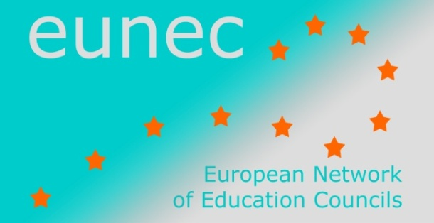 | 17 November 2013
 | EUN/EC/DOC/030

Main Policy Lines in Education and Training

May 2013 - October 2013

- UNESCO

Promoting inclusive teacher education

This publication set is a series of five guides designed for anyone who wants to do advocacy to bring about improvements in pre-service teacher education towards more inclusive education. They discuss challenges and barriers to inclusive education in different areas of teacher education and outline ideas for advocates to consider and adapt according to their specific contexts for effective advocacy towards more inclusive practices.
Introduction
Policy
Curriculum
Materials
Methodology

Envisioning education in the post-2015 development agenda
UNESCO, July 2013

The Global Thematic Consultation on Education in the Post-2015 Development Agenda is co-led by the UNESCO and the UNICEF, with the support of the Governments of Senegal, Canada and Germany, and the William and Flora Hewlett Foundation. The overall objective of the consultation was to assess the progress and remaining challenges in meeting the education-related Millennium Development Goals (MDGs) adopted in 2000 and the broader Education for All (EFA) goals. ‘Equitable, Quality Education and Lifelong Learning for All’ is proposed as the overarching goal for education.
The key message from the consultation is that universal access to quality education and lifelong learning is key to sustainable development in the post-2015 framework. The provision of education contributes to the eradication of poverty, the promotion of social cohesion, good governance and improved health and gender equality.
The consultation identified several gaps linked to access, quality and learning, equity and gender equality:
- Excluding primary education, progress on education goals remain uneven
- The education-related MDGs are perceived as having narrowed the focus on access and completion
- Education and training are not meeting the needs and demands of all young people to thrive and participate fully in society
- Exclusion from education occurs most often among the most vulnerable groups such as girls, orphans, migrants, rural people, children with disabilities, refugees, linguistic and cultural minorities etc.
- Girls continue to account for the largest number of out-of-school children of primary school age
- Inadequate attention to financial, human capital and resource constraints ( inadequate focus on well-trained teachers)
- The emphasis on global targets has imposed one-size-fits-all targets for countries, irrespective of countries’ diverse starting points and financial resources
The recommended priorities of the consultation:
- Expanded access to quality learning should be ensured for all and at all levels of education
- Focus attention on the quality education
  - Well-trained and motivated teachers and school leadership
  - Relevant, measurable and equitable learning outcomes
  - Internalizing the principles of sustainable development
  - Strengthening training and skills for work and life
  - Ensuring safe and healthy learning environments
- Focus on equity: most vulnerable groups to acquire literacy, numeracy and other skills
- Gender equality: enhanced access to post-basic and post-secondary education
Framing the goal
Four priority areas:
- All girls and boys are able to access and complete quality pre-primary education of an agreed period
- Equal access to and completion of a full course of quality primary schooling
- All adolescent girls and boys are able to access and complete quality lower secondary/secondary education
- All youth and adults, particularly girls and women, have access to post-primary and post-secondary learning
http://unesdoc.unesco.org/images/0022/002230/223025e.pdf

Glossary of curriculum terminology
UNESCO, September 2013
The curriculum is increasingly viewed as laying the foundation for comprehensive educational reforms aimed at achieving quality learning outcomes. Contemporary curriculum development processes more frequently involve public discussion and consultation with a range of stakeholders.
The curriculum-related terminology is frequently used interchangeably which may generate confusion and misinterpretation. For this reason the IBE (International Bureau of Education) developed this Glossary.
The main purpose of the Glossary is not to establish standard universally applicable definitions. It is intended to be a working reference tool that can be used in a range of activities and help to stimulate reflection among all those involved in curriculum development initiatives. The glossary is also very useful in helping curriculum developers and educational stakeholders have a common understanding of terms that are often used in curriculum development, implementation and assessment but with varied meanings.
The Glossary is available online and it will continue to be revised based on feedback from specialist and users.
http://unesdoc.unesco.org/images/0022/002230/223059e.pdf

Education transforms lives
UNESCO, 2013
Education has a unique power to act as a catalyst for wider development goals. Therefore all children and young people- regardless of their family income, where they live, their gender, their ethnicity, whether they are disabled-should benefit equally from this power. To unlock the benefits of education, all children need the chance to complete not only primary school but also lower secondary school. Moreover, education needs to be of good quality so that children actually learn.
Given education’s transformative power, it needs to be a central part of any post-2015 global development framework.
The transformative power of education works in the following fields:
- It increases women’s and men’s job opportunities
- More equal education leads to faster growth
- It reduces child marriages and reduces early births
- Mother’s education saves children’s lives
- Education saves mother’s lives
- Maternal education improves child nutrition
- Educated people are more tolerant and more concerned about their environment
Download the full booklet of infographics showing ‘Education Transforms’

