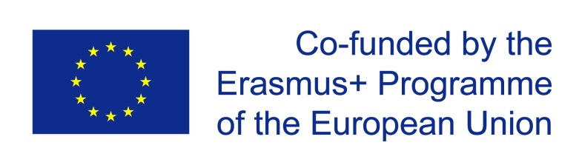
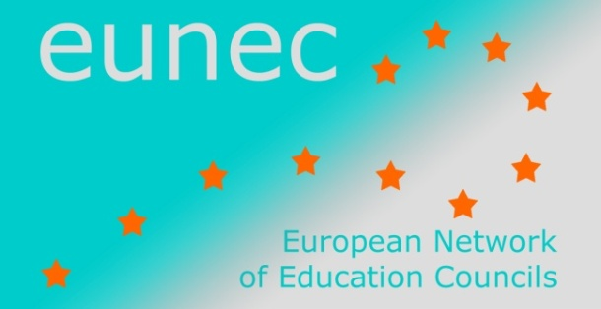

Main Policy Lines in Education and Training

(May 2014 – October 2014)

- UNESCO

ISCED-F 2013 Manual
UNESCO, Institute for Statistics, 2014
The International Standard Classification of Education (ISCED) is a framework for assembling, compiling and analyzing cross-nationally comparable statistics on education. ISCED (first developed in the mid-70s) is a product of international agreement and was adopted formally by the General Conference of UNESCO Member States.
The latest revision, ISCED 2011, introduced for the first time a classification of levels of educational attainment based on qualifications (ISCED-A).
In a separate process, fields of education are examined to establish an independent but related classification. This new classification is referred to as the ISCED-F, ISCED Fields of Education and Training. A field is a ‘broad domain, branch or area of content covered by an education programme or qualification’. Fields are not defined within levels of education.
The aim of this manual is to offer guidelines on how to apply the ISCED-F. The detailed classification is described in Appendix I.
The manual

Global Citizenship Education. Preparing learners for the challenges of the 21st century.
UNESCO, 2014
Global citizenship education (GCE) is one of the strategic areas of work for UNESCO’s Education Programme (2014-2017) and one of the three priorities of the UN Secretary-General’s Global Education First Initiative (GEFI) launched in September 2012.
Global Citizenship Education is presented as a conceptual shift in that it recognizes the relevance of education in understanding and resolving global issues in their social, political, cultural, economic and environmental dimensions. It acknowledges the role of education in moving beyond the development of knowledge and cognitive skills to build values, soft skills and attitudes among learners.
This report seeks to enhance understanding around GCE and its implications for educational content, pedagogy and practice. It attempts to provide common perspectives and to clarify some of the contested aspects of GCE. The report provides guidance on how to translate GCE into practice.
The full report

