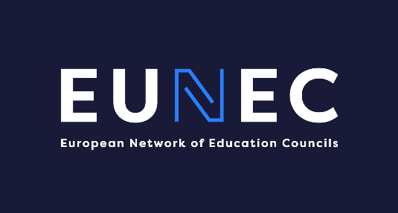
EUN/2022/DOC/017
10 November 2022

Agenda EUNEC Exchange
22 November 2022
14.30 – 16.30 h (Brussels time), digital meeting

- Looking back at previous exchange sessions
- 21 April 2021: How did our councils and our education systems deal with the impact of COVID on education?
EUNEC exchange on education councils in times of Covid-19 pandemic | Eunec
- 15 October 2021: How did our education systems work towards recovery and what can be the role of education councils?
EUNEC exchange on the role of education councils for recovery | Eunec
- Focus of the exchange: follow up to which extent any shift in policy due to the COVID crisis is becoming sustainable or not
  - Short presentation by the Portuguese Education Council (Conceição Gonçalves, Ana Rodrigues, Ercília Faria)
“Education in Portugal: a few lessons learned from the pandemic”
Efeitos da pandemia COVID-19 na educação: Desigualdades e medidas de equidade - Conselho Nacional de Educação (cnedu.pt)
EDUCAÇÃO EM TEMPO DE PANDEMIA |Problemas, respostas e desafios das escolas - Conselho Nacional de Educação (cnedu.pt)
EE2020_WEB_04.pdf (cnedu.pt)
  - Short presentation of the recommendation of the Flemish Education Council (Carine De Smet): Standing up for resilient education | Vlor
  - Input by EUNEC members
Input based on recommendations, reports, projects focusing on shifts in policy due to the COVID crisis.
Possible topics:
  - Learning losses;
  - Digitalisation;
  - Equal opportunities;
  - Wellbeing;
  - …

